Journal ideas:
Biogeochemistry - Springer Nature (first choice)
- 12k word length limit
- Results, Discussion, Conclusion paper structure
Frontiers in Microbiology: Microbial Physiology and Metabolism
Metabolites - MDPI

Substrates and metabolic shifts associated with increased methane emissions in unrestored hypersaline salterns
Clifton P. Bueno de Mesquita^{1,+}, Andrew P. Freiburger^{2,++}, Susanna M. Theroux¹, Jinglie Zhou¹, Wyatt H. Hartman¹, José P. Faria², Filipe Wang Liu², Christopher S. Henry², Chaevien S. Clendinen³, Karl K Weitz³, Robert P. Young³, David W. Hoyt³, Susannah G. Tringe^{1,4,*}
¹Department of Energy Joint Genome Institute, Lawrence Berkeley National Laboratory, Berkeley, CA 94720, USA
²Mathematics and Computer Science Division, Argonne National Laboratory, Argonne, IL, USA
³Environmental Molecular Sciences Laboratory, Pacific Northwest National Laboratory, Richmond, WA 99352, USA
⁴Environmental Genomics and Systems Biology Division, Lawrence Berkeley National Laboratory, Berkeley, CA 94720, USA
⁺Current affiliation: Cooperative Institute for Research in Environmental Sciences, University of Colorado, Boulder, CO 80309-0216
⁺⁺Current affiliation: Department Chemical and Biological Engineering, Northwestern University, Evanston, IL 60208
*Corresponding author sgtringe@lbl.gov

Abstract (150-250 words)
Hypersaline environments, such as unrestored saltern complexes, are inhabited by microorganisms that are uniquely adapted to high salinity and govern the unique biogeochemical cycles of this habitat. Hypersaline former salterns in the San Francisco Bay were previously demonstrated to exhibit elevated methane emissions compared to nearby restored salterns or undisturbed salt marshes, likely due to some combination of archaeal methylotrophic methanogenesis and bacterial degradation of methylphosphonate. Restoring these wetlands can therefore reduce greenhouse gas (GHG) emissions and increase carbon sequestration, but ensuring successful remediation requires understanding the underlying biogeochemistry. Here we explore several mechanistic hypotheses of methane production through metabolic modeling, using metagenomics and metabolomics measurements for two unrestored hypersaline salterns, an adjacent reference wetland, and a restored saltern. We focused the measurements and modeling on pathways of methylated compound cycling, which differed significantly among the three sites in terms of gene relative abundances. Key experimental findings include: site-specific metabolomes reflect adaptations to salinity, and methylphosphonic acid increases methane production while dimethylamine increases N₂O production in substrate addition experiments. These findings were corroborated by metabolic modeling, whereby the trace consumption of methylphosphonic acid reproduced the experimentally measured methane emissions, providing further evidence for methylphosphonate being a primary methanogenic substrate in these saltern environments. Our work elucidates an environmental biogeochemical cycle that can inform future remediation efforts, and more broadly demonstrates the valuable synergy of experimental inspection and metabolic modeling for developing a mechanistic understanding of the biogeochemistry of a given ecosystem.

Introduction
Earth contains a wide variety of natural and artificial ecosystems that contain high concentrations of salt. These include certain hot and cold springs, coastal lagoons, lakes of varying pH (acidic, neutral, alkaline), deep sea brines, arid soils, wetlands, and industrial salterns (1–4). High salinity challenges the survival of most organisms by disrupting osmotic regulation and ion-based cellular machinery (2, 5). Indeed, when combined with other factors, salinity is one of the key factors contributing to potential habitability limits to life on Earth (6). But saline to hypersaline environments, even those saturated with salt, are still inhabited by salt-tolerant (“halotolerant”) and salt-loving (“halophilic”) microorganisms that evolved to survive high salinity and form unique communities (7, 8). Known adaptations include the “salt-in” strategy, in which organisms have acidic proteomes that retain function in the presence of high intracellular ion concentrations, and the “salt-out” strategy, in which organisms maintain cellular function by excluding salts via accumulation of compatible solutes in their cytoplasm (9, 10). Only halophiles such as aerobic archaeal order Halobacteriales, the anaerobic bacterial order Haloanaerobiales, and certain methanogens use the “salt-in” strategy (11) while halophilic bacteria, and some archaea, use the “salt-out” strategy. A wide range of molecules have been identified as compatible solutes, such as choline, ectoine, hydroxyectoine, glutamate, glutamine, glycine betaine, and trehalose (12–14).
The biogeochemistry of hypersaline environments, typically defined as those environments with greater than twice the salinity of seawater (i.e., > 7% salt) (15), is influenced both directly by the salinity and indirectly via the altered metabolic activities of organisms in these environments (16). At the highest salinities, certain metabolic pathways such as acetoclastic or hydrogenotrophic methanogenesis, autotrophic nitrite oxidation, and acetate-oxidizing dissimilatory sulfate reduction do not generate enough energy to sustain osmoregulation (17). Microbial growth in these environments can be nitrogen limited (18) but is more commonly phosphorus limited (19) (20) (21).
Organisms contribute compatible (osmolytic) solutes to the ecosystem (16), some of which can be further metabolized as a substrate for other organisms. Glycine betaine (GB), for example, is produced in high abundance in hypersaline environments by plants, archaea, and cyanobacteria (22) and can be degraded into methane (23, 24), N,N-dimethylglycine, sarcosine, L-serine, and pyruvate (25). In the ruminant gut, trimethylamine, dimethylglycine, and methionine can also be produced from GB (26). A second example is trehalose, a ubiquitous and multifunctional disaccharide that can act as a compatible solute as well as a cryoprotectant and energy storage compound that can also be converted into glycogen or glucose (27, 28). Compatible solutes and osmoprotectant sugars can further become sources of carbon, nitrogen, and sulfur (29, 30) during times of lower salinity when they are less needed for their primary function as osmoprotectants (16).
Despite previous studies showing that methane emissions generally follow a log-linear decrease with increasing salinities (31–33), we’ve previously observed elevated methane emissions in hypersaline unrestored salterns (34). This log-linear decline is attributed to the sulfate content of seawater, as the higher sulfate concentrations associated with higher salinities allow sulfate reducers to outcompete methanogens for acetate and hydrogen. At salinities beyond seawater, however, halophilic or halotolerant methanogenic taxa adapted for these resource conditions thrive, even in the presence of high sulfate (15). These salt-adapted methanogens are archaeal methylotrophs (11, 15, 35, 36) that consume methylated molecules like tri- and di-methylamine (TMA and DMA, respectively) and glycine betaine (GB) (37) to generate methane, as opposed to the more common acetoclastic or hydrogenotrophic pathways (38). Hypersaline habitats may also harbor aerobic bacteria that generate methane as a by-product of phosphate scavenging from methylphosphonates (39–42), which are produced by marine taxa such as Nitrosopumilus (43).
Whether the observed methane emission is explained by classical archaeal methanogenesis using organic molecules such as GB as substrates, or by noncanonical pathways such as methylphosphonate degradation, remains unknown. Our previous work found that the phnGHILMJ genes for the carbon-phosphorus lyase pathway, which would be used for methylphosphonate degradation, were among the most abundant of all studied saline-hypersaline environments (34, 44), supporting that methylphosphonate is an important methanogenic substrate in these hypersaline environments. Determining the methanogenic mechanism(s) would facilitate GHG mitigation via restoration efforts and expand basic understanding of these hypersaline microbiomes. Here, we build on previous work (34) by combining metagenomics, metabolomics, and laboratory microcosms with genome-scale metabolic modeling to identify critical differences across four adjacent yet distinct wetlands. We use metabolic modeling and substrate addition experiments in both microcosms and pure cultures to identify methanogenic substrate potential and whether the hypothesized methanogenic substrates could recreate the experimentally measured methane flux. Through this comprehensive study, the evidence suggests that methylphosphonate is the primary methanogenic substrate, revealing that restoration efforts should …
[Proposed Figure 1: a conceptual overview of the study system -- the restoration / salinity-sulfate gradient, the two candidate methane pathways (aerobic methylphosphonate degradation and anaerobic betaine->TMA methylotrophic methanogenesis), and the five converging lines of evidence -- would orient the reader; a draft is provided in the clauded_insights folder.]

Methods

Field sites and sampling
Details about field sites and initial sampling and data collection are presented in Zhou et al. (2022) (34). Briefly, three 15 cm deep sediment cores were taken in July, 2014 from each of two unrestored salterns (R1, R2), one restored saltern (SF2), and one reference wetland (R2A) in the South San Francisco Bay, USA (37.496791˚N, 122.13340˚W). Water temperature, pH and dissolved oxygen (DO) were measured in the field with a YSI probe (model 6920-v2, YSI Inc., Yellow Springs, OH, USA). Methane flux measurements were taken by capping the bottom of the sediment core and placing it in an airtight 2 L Mason jar hooked up to an ultraportable Greenhouse Gas Analyzer (Los Gatos Research, Mountain View, CA, USA) with airtight Bev-A-Line IV connective tubing (US Plastic Corp, Lima, OH, USA) and recording methane flux for 5 minutes.
Sediment cores were then split into a 0-5 cm deep section (D1), and a 5-15 cm deep section (D2). DNA was extracted and 16S rRNA gene amplicons were sequenced on an Illumina MiSeq while total metagenomic DNA was sequenced on an Illumina HiSeq 2500; amplicons and metagenomes were processed as detailed by Zhou et al. (2022). Sediments were sent to the UC Davis Analytical Laboratory and assessed for total carbon, nitrogen, and phosphorus concentrations, DTPA extractable concentrations of Zn, Mn, Cu, and Fe, 2 M KCl extractable concentrations of nitrate and ammonium; ammonium acetate extractable concentrations of base cations Ca⁺, Na⁺, K⁺, and Mg²⁺, Olsen extractable concentrations of inorganic phosphate, saturated paste extract concentrations of sulfate (measured with Inductively Coupled Plasma Emission Spectrometry (ICP-AES)) and chloride (quantified with the absorbance of ferric thiocyanate at 480 nm), which we used as a proxy for salinity (45)), and loss on ignition percentage organic carbon.

Metagenomics
The 24 metagenomes were quality filtered and trimmed with BBtools, assembled with MEGAHIT (46), and annotated with the standard analysis pipeline (v4.10.2) on the Joint Genome Institute’s IMG/M server (47). The functional profile of KEGG Orthologies (KOs) was downloaded from IMG and normalized with the DESeq2 R package (48). To build on the findings of Zhou et al. (2021), who reported differences in abundance of some genes involved in methylotrophic methanogenesis and methylphosphonate cycling, we developed a list of other KOs (Table S1) of potential interest that are involved in the cycling of methylated compounds using BioCyc and relevant literature (49, 50). This list includes genes involved in various pathways of degradation or biosynthesis of trimethylamine, methylamine, methanol, glycine betaine, dimethylsulfide, methylthiopropanoate, and dimethylsulfoniopropionate.

Metabolomics
Soils were shipped to the Environmental Molecular Sciences Laboratory (EMSL) at Pacific Northwest National Laboratory for metabolomic analyses. Nuclear magnetic resonance (NMR) analysis was performed on pore water. To collect pore water, sediment samples were centrifuged in either their original 50 mL centrifuge tubes or, in cases where the sediment mass exceeded centrifuge limitations, a portion of the sediment was transferred to a clean 50 mL centrifuge tube. Centrifugation was conducted at 6000 x g (rcf) in a fixed-angle rotor for 60 minutes at 4°C. Aliquots (0.5 mL) were transferred to pre-rinsed (10 x 0.5 mL rinses with Milli-Q ASTM Type 1 water) 0.22 μm 0.6 mL capacity nylon membrane spin-filters and spun to filter at 10000 rpm for 5 minutes at 4°C. Filtrate aliquots of 180 μL were transferred to separate vials and 20 µL of Chenomx internal standard solution (consisting of 0.2% (w/v) NaN₃ and 5.02 mM 2,2-dimethyl-2-silapentane-5-sulfonate-d6-sodium salt (DSS-d6) in 100% D₂O, Chenomx Inc., Edmonton, AB) was added to each and mixed prior to transferring to Bruker 3.0 mm OD glass NMR tubes for measurement. All NMR spectra were measured at a field strength of 17.6 T (750.2 MHz ¹H) on a Bruker Avance III spectrometer equipped with a Bruker 5mm HCN TCI CryoProbe with Z-gradient. Sample temperature was regulated at 25.0°C. The 1D ¹H NOESY experiment with low power, continuous wave pre-saturation of the water signal during the relaxation delay (Bruker pulse program ‘noesypr1d’) was acquired for all samples with the following parameters, spectral width of 12.0 ppm (9.0 kHz), a relaxation delay of 1.5 s, a mixing time of 100 ms, an acquisition time of 4.0 s (72070 total points), and a total of 2048 transients were coadded for each spectrum. Post-acquisition processing included zero-filling to 262144 real points and multiplication of the FID by a decaying exponential (0.3 Hz line-broadening) using Bruker’s Topspin 3.6.3. Spectra were imported into Chenomx NMR Suite version 8.6 Professional (Chenomx Inc., Edmonton, AB) for final pre-processing, including baseline correction (Chenomx spline algorithm), and metabolomic profiling. Metabolite identification and quantitation was based on matching the chemical shift and J-coupling intensity of experimental signals to compound signals in the Chenomx spectral library. While we attempted to collect metabolomic data for all 24 sediment samples, due to issues with the samples and the presence of paramagnetic ions, only 1 restored saltern sample was able to yield viable spectra for analysis. For additional confirmation of several metabolites, 2-D NMR experiments were employed (1H-13C HSQC, 1H TOCSY etc.). Additionally, a subset of key metabolites (amines central to the study) were confirmed by “spike-in” amendments of metabolite standards into actual representative samples.
Additional methods were attempted with the remaining 5 samples, including a pooling and concentration step to concentrate the samples 5x, but without success. In addition to NMR, several other methods were used to search for specific compounds of interest, including methylated phosphorus and sulfur compounds. Methylphosphonates were searched for using 1D ³¹P NMR and 2D ³¹P-¹H NMR on a subset of samples. Another subset of 1-4 samples were also tested using single and double NaOH/EDTA extraction, methanol extraction, Na2CO₃ extraction, and longer acquisition times. The compounds dimethylsulfide, dimethyl sulfone, dimethylproponiosulfate, methylphosphonic acid and dimethyl methylphosphonate were determined by headspace gas chromatography mass spectrometry (GCMS) using high purity reference standards (Sigma-Aldrich St. Louis, MO). Presence or absence of these compounds was confirmed by a targeted retention time with exact mass approach using a high mass resolution Agilent 7250 QTOF Time of Flight Mass Spectrometer coupled to an Agilent 8890 Gas Chromatograph (Agilent Technologies Inc., Santa Clara, CA). For each, approximately 10 ml of sample was transferred to a 20ml vial and sealed with a Teflon lined cap with an opening in the cap for syringe sampling. The samples were allowed to stand at room temperature for 72 hours when 100ul of headspace was syringe transferred manually to the GC injection port held at 240˚C for analysis. The analytical separations were performed using an Rxi-624Sil-MS, 30m x 0.25mmID x 1.4 umdf, GC column (Restek Corp., Bellefonte, PA.). Helium was used as a carrier gas at a constant 24 psi pressure. The GC oven gradient profile began at 35˚C initial temperature with a 2.0-minute hold, then ramped at 30˚C/min to 300˚C and held for 1.0 minutes. Metabolite names and IDs were translated across databases using MetaCyc’s “Metabolite Translation Service” tool, and manually with Model SEED for any that remained untranslated.

Metabolic Modeling
Metabolic models were developed using dereplicated medium and high quality metagenome-assembled genomes (MAGs) that were assembled from the 24 metagenomes and previously presented in Zhou et al. (2021). Models were built from these MAGs in KBase (51, 52) by first importing the assemblies into KBase and annotating them with RAST (53) through the “MS2 - Build Prokaryotic Metabolic Model” tool in KBase (version 1.0.0), with default settings, auxotrophic media, and gapfilling with a minimum of 0.1 $\frac{mmol}{hr * g_{dw}}$ biomass growth. For the one methanogen MAG, a methanogenic dimethylamine and hydrogen media was used.
The MAG-derived models were subjected to the following series of constraints and objectives to better follow their biology. First, the biomass compound of each model was constrained to its relative abundance in each simulated sample (based on read mapping), which scales the member’s metabolism to match its contribution in the sample’s consortium and specifically allows the simulated methane emission to quantitatively approximate the organism’s in situ production. The models for methylphosphonate-consuming organisms were simulated with a fixed ratio of inorganic to organic phosphate (0.07 yielded the best fit to the experimental data) to create a realistic consumption and excretion profile. The betaine-utilizing organisms were simulated with a betaine consumption rate of 0.1 $\frac{mmol}{hr * g_{dw}}$, based on the experimental turnover rate of betaine consumption (54). One TMA was excreted for each consumed betaine, which was assumed to be demethylated by other organisms in the community in proportion to the substrate addition experiment with TMA in Figure 4 where 1 TMA produced 0.06 methane: i.e. the estimated methane emission flux from betaine was assumed to be 0.06 x TMA excretion flux. The metabolic models were finally minimized to the consumption of lactate (the carbon source) to follow evolution’s directive of finding the most efficient metabolism to achieve a given biomass.
Lactate was selected as the simulated carbon source because it required among the fewest reactions to be gapfilled among the potential carbon sources for all methylphosphonate- and betaine- consuming members (see Figure S9), partially because in one step it can directly convert into pyruvate via lactate dehydrogenase. This enzymatic capacity is prevalent in hypersaline archaea (55) and lactate can be generated in these environments during pyruvate metabolism (56), so it is a plausible available sugar in this ecosystem. Measuring lactate in the metabolomics data at every site further supports the selection of this carbon source. Glycerol and acetate are other candidate carbon sources – supported by the above literature, our metabolomics data, and the requisite number of reactions to be gapfilled – and could be simulated, but would not change the consumption profiles of betaine and methylphosphonate.
Linear regression between the experimental and simulated methane emissions revealed explanatory power of the experimental measurements by the modeling results. The modeling methane fluxes were converted into the experimental units $\frac{umol}{m^{2}*day}$ through unit conversions
$\frac{mmol}{hr * g_{DW}}*\frac{1}{area_{cs} [m^{2}]} * \frac{1000 umol}{1 mmol} * \frac{24 hr}{1 day}*\frac{g_{DW}}{ug_{DNA}}*\frac{ug_{DNA}}{g_{soil}}*\frac{g_{soil}}{cm^{3}}*\frac{cm^{3}}{container}$
for direct comparison and consistent flux interpretation across the paper. The soil density was estimated from other studies of this same region to be 0.7$\frac{g_{soil}}{cm^{3}}$. The values were further normalized by DNA measurements to control for variability in biomass density among the samples. Pearson coefficients were calculated between these two sets of methane concentrations, and linear equations of the line-of-best-fit from these correlations were reported.

Substrate additions
Sediment for a substrate addition experiment was collected from Pond R2 on October 8th, 2021. The salinity of the pond water at the time of sampling as measured with a YSI probe was 8.5% (85 ppt). Sediment was collected by drilling through ~30 cm of solid salt crystals, which were covered with ~20 cm water (Figure S1), and passively filling sterile Falcon containers with sediment and water, and transferring the slurry to sterile glass bottles. 10 mL of substrate and 10 mL of sediment slurry were added to sterile 75 mL glass bottles. The following substrates and concentrations were added for the anaerobic substrate addition, with three replicates each: sterile deionized water control, 100 mM sodium acetate, 100 mM sodium formate, 100 mM betaine, 10 mM dimethylsulfide, 100 mM trimethylamine, 100 mM dimethylamine, 100 mM methylamine, 100 mM methanol. The following substrates and concentrations were used for the aerobic substrate addition, with three replicates each: sterile water control, 100 µM dimethyl methylphosphonate, 100 µM methylphosphonic acid. In both experiments, since 10 mL of these substrates were added to and diluted by 10 mL sediment slurry, the actual concentrations in the bottles were nearly halved, depending on the natural concentrations of the compounds in the slurry.
A subset of sediment slurry was left to sit at room temperature with aerobic atmospheric conditions, while another subset was left to sit uncapped in a Type B vinyl anaerobic chamber (Coy Laboratory Products Inc., Grass Lake, MI, USA) outfitted with two palladium chloride oxygen scrubbers and filled with a mix of 90% N₂, 5% CO₂, and 5% H₂ gas (Alliance Gas Products, Oakland, CA, USA). Actual concentrations of H₂ ranged from 2.5 - 3.5% through the course of the experiment; O₂ was undetectable on the Coy Anaerobic Monitor 12 (CAM-12) in the chamber. Glass bottles containing substrates were also left uncapped in the anaerobic chamber at this point. After 20 h of equilibration and oxygen scavenging, 10 mL of sediment slurry was added to the glass bottles, which were then capped with butyl rubber stoppers and crimped with aluminum seals. At this point, aerobic sediment slurry was also added to the aerobic substrate bottles, which were then capped with butyl rubber stoppers and crimped with aluminum seals. 15 mL headspace gas was sampled immediately after crimping and every other day for 14 days and injected into evacuated 12 mL Exetainer vials (Labco, Exeter, UK) for overpressurized storage (57); after each gas extraction, 15 mL of anaerobic chamber air (anaerobic experiment) or atmospheric laboratory air (aerobic experiment) was injected back into the bottles to maintain pressure. CO₂, CH₄, and N₂O were quantified on a SRI GC 8610-V gas chromatograph (SRI Instruments, Torrance, CA, USA) equipped with an AS-210 autosampler and a thermal conductivity detector, electron capture detector, and flame ionization detector at the Yale Analytical and Stable Isotope Center. Lab air blanks were run in between each sample to minimize potential carryover. Gas production over time was calculated by taking into account the measured concentrations, the headspace volume, the amount of gas extracted for the measurement, and the amount of ambient (aerobic laboratory air or anaerobic chamber air) air added into the bottles.

Culturing
To build on the amplicon and metagenomic microbial analyses, efforts were made to isolate anaerobic methanogenic archaea and aerobic methane-producing bacteria based on previous work (44, 58). The substrate incubations were used to start enrichment cultures. Following the experiment, 1 mL of sediment slurry was transferred to septum bottles containing MM/W medium (59–61) and the same concentration of each substrate as the experiment. Following one month of enrichment, 1 mL were transferred to MM/W medium agar plates in the anaerobic chamber described above. Colonies showed growth after 1 month and individual isolated colonies were replated. For aerobic culturing, sediment slurry from aerobic microcosm was streaked onto plates with Difco Marine Agar 2216 with salt concentration augmented to 10% (henceforth “hypersaline marine agar”). Colonies showed growth after 1 week and individual isolated colonies were replated. Serially diluted slurries of sediments from unrestored salterns R1 and R2 were also streaked on marine agar without any enrichment.
To identify the isolates, we amplified the full length 16S rRNA gene with the 27F/1492R primers for bacteria, partial length 16S rRNA gene with the 519F/915R primers for archaea, and partial mcrA gene with the mlas-mod-F/mcrA-rev-R primers for methanogens (62). PCR reactions were created with 10 µL DreamTaq Green PCR Master Mix (Thermo Fisher), 1 µL forward primer (10 µM), 1 µL reverse primer (10 µM), 8 µL autoclaved water, and 1 µL of genomic DNA. PCR was performed with the following conditions: 95˚C for 3 min, 29 cycles of 95˚C for 30 seconds, 55˚C for 30 seconds, and 72˚C for 2 minutes, followed by a final step of 72˚C for 5 minutes. Sanger sequencing was performed at the University of California Berkeley sequencing core facility. Geneious Prime (63) was used to trim and merge reads and BLAST consensus sequences to identify closest matches in the NCBI databases. Full length 16S sequences for the isolates are available on NCBI GenBank via accessions OP902298-OP902308.
Upon identification of two Halomonas isolates, those isolates were sent for full genome sequencing with an Illumina NovaSeq 6000 and paired-end 150 bp chemistry (Novogene Co, Beijing, China). Reads were quality assessed with FastQC v0.11.09 (64), quality filtered with BBTools v38.22, low-complexity filtered with PRINSEQ v0.20.4 (65), assembled with SPAdes v3.15.3 (66); assemblies were then quality assessed with CheckM v1.0.18 (67), annotated with RAST v1.073 (53), and classified taxonomically with GTDB-Tk v1.7.0 (68), all of which was implemented in KBase (51) and is publicly accessible with narrative ID 139158. Furthermore, the isolates were inserted into a phylogenetic tree with 50 closely related reference genomes using 49 single marker clusters of orthologous genes (COGs) in KBase. Genomes were also annotated with KEGG orthology with BLASTkoala (69). Whole genome sequences for the two Halomonas isolates are available on NCBI GenBank via accession PRJNA992430.
The two Halomonas isolates were subsequently tested for capacity to produce CH₄ from methylphosphonate (MPn). Isolates were grown in sealed 75 mL bottles for 48 h at 28˚C and 200 rpm in 10 mL of one of three different media: marine broth 2216 (Difco Laboratories Inc., Detroit, MI, USA), marine broth with MPn instead of phosphate, and marine broth with no inorganic phosphate. Headspace gas samples (15 mL) were taken at the initial and final timepoints and injected into 12 mL evacuated vials (Labco, UK). Headspace CH₄, CO₂, and N₂O were quantified on a gas chromatography at the Yale Stable Isotope Center as described above. Growth was determined by measuring optical density at 600 nm (OD₆₀₀).

Analyses
Differences in gene abundances among the three habitat types were tested with Kruskal-Wallis tests. Metabolomic data were analyzed using a combination of R (70), BioCyc (25), and MetaboAnalyst (71). Metabolites were uploaded to BioCyc to acquire a list of pathways and reactions producing and consuming each metabolite (Table S2). Correlations between metabolite concentrations and methane fluxes and gene abundances were analyzed with Pearson’s r, Spearman’s rho, and Kendall’s tau metrics, with p values corrected with false discovery rate (FDR). Only metabolites present in at least three samples were analyzed statistically (n = 36). Differences in metabolite concentrations between unrestored salterns and the reference wetland were tested with Wilcoxon tests. Heatmaps were plotted with the pheatmap R package (72). Enrichment analysis and pathway analysis were performed with MetaboAnalyst using the list of metabolites, and the concentrations of metabolites, respectively. Dissimilarity of metabolomic composition and taxonomic composition was calculated with the Bray-Curtis dissimilarity metric, calculated on square-root transformed data. Correlations between Bray-Curtis dissimilarities were calculated with Mantel tests.
N₂O, CO₂ and CH₄ concentrations from the substrate addition experiment were analyzed with repeated-measures ANOVA to test for the effect of substrate, time, and their interaction. These models were implemented as mixed effects models with substrate, time, and their interaction as fixed effects, and microcosm ID as a random effect, implemented with the ‘lmer’ function in the lme4 R package (73). Models were tested for significance with a Type III ANOVA test implemented with the ‘Anova’ function in the car R package (74). Separate models were run for each experiment (anaerobic and aerobic) for each of the three gases. Additionally, the effect of substrate on the cumulative gas production over the course of the whole experiment (Day 14) was assessed with a Type III ANOVA and pairwise comparisons were performed with a Tukey posthoc test implemented with the emmeans R package (75). All R analyses were performed with version 4.0.2 (70).
The experimental relative abundances were correlated with the experimental methane fluxes to empirically inspect which organisms contribute to the observed methanogenesis.
The metabolomics concentrations were also correlated with the relative abundances to empirically inspect how the organisms interacted with the substrates and syntrophic compounds.

Results
CH₄ emissions in the unrestored salterns ranged from 490 to 1607 µmol CH₄ m⁻² d⁻¹, and were significantly higher in the hypersaline unrestored salterns than in the adjacent restored saltern and unaltered reference wetlands (34). Emissions from the unrestored salterns were also among the highest measured across the whole natural salinity gradient in the San Francisco Bay and Delta; only emissions from the oligohaline Mayberry Farms restored wetland were as high (76).

Metagenomics
39 of the 60 selected KOs involved in methylated compound cycling were present in at least one metagenome (Table S1). Hierarchical clustering of the 24 metagenomes by the relative abundance of those 39 KOs resulted in three clear clusters representing the three different sample types (saltern, restored saltern, reference wetland) (Figure 1). Many of the genes involved in DMS, DMSP, TMA, DMA, MMA cycling showed significant differences in relative abundance (Figure 1, Kruskal-Wallis test, P_{FDR} < 0.05). In particular, the unrestored salterns had greater relative abundance of several MMA degradation genes (folD, purU, ftfL), several glycine betaine degradation genes (soxBD, sdaA), the glycine betaine biosynthesis gene gbsB, and two DMSP degradation genes (dddL, dmdA). The reference wetland had greater relative abundance of several aerobic TMA degradation genes (tmd, mauAB, fae, gfa), one of the GB degradation genes (SARDH), one of the GB biosynthesis genes (CMO), and two DMS degradation genes (sfnG, msuD). The restored saltern had greater relative abundance of the DMS photosynthesis gene ddhA and the GB degradation gene Bhmt. In sum, the microbiomes at each site differed in their capacity to metabolize each of these substrates, both in terms of gene relative abundances and pathways utilized.

Metabolomics
A total of 50 metabolites were identified with NMR across the 19 samples with successful extractions and clear spectra. Across all of the samples analyzed, the most abundant compounds according to NMR were acetate, glucose, betaine, fructose, sucrose, proline, glycerol, and trehalose. The most prevalent compounds (i.e., present in the most samples) were acetate, acetone, alanine, betaine, N,N-dimethylglycine, propylene glycol, and trehalose, which were the only 7 metabolites that were present in all 19 samples with viable NMR spectra. In addition to the metabolites detected with NMR, five additional metabolites - dimethylsulfide, dimethyl sulfone, dimethylsulfoniopropionate, methylphosphonic acid, and dimethyl methylphosphonate - were detected in all samples analyzed with GC-MS (n = 21), although methylphosphonic acid was present only at trace levels. The only qualitative differences in the GC-MS spectra were that dimethyl methylphosphonate was present in trace levels in unrestored pond R1 while it was qualitatively more strongly detected in other samples. In contrast to the GC-MS results, methylphosphonates were not detected in the subset of samples tested with ³¹P NMR or LC-MS. The known and described reactions and pathways involving the production or consumption of the 55 metabolites are presented in Table S2.
Enrichment analysis (71) demonstrated that aminoacyl-tRNA biosynthesis, valine, leucine and isoleucine biosynthesis, alanine, aspartate and glutamate metabolism, arginine biosynthesis, and butanoate metabolism pathways were the most significantly over represented in the list of metabolites (Figure S2). Pathway enrichment analysis using KEGG metabolite databases for E. coli (71) showed that Alanine, aspartate, and glutamate metabolism was the pathway most over-represented by the metabolite concentrations.
Metabolite profiles from all of the unrestored saltern samples clustered together, while the reference wetland was split into two clusters based on sediment depth (Figure 2). There was also substantial variation among the three 0-5 cm depth samples from the reference wetland - replicate C had high levels of ethanol, arginine, glucose, fructose, sucrose, 4-aminobutyrate, and proline, while replicates A and B had high levels of N,N-Dimethylglycine, benzoate, fumarate, isovalerate, aspartate, glutamate, 2-oxoisocaproate, and 3-methyl-2-oxovalerate. The restored wetland had a distinct metabolome compared to the unrestored and restored saltern, but only one sample produced analyzable spectra, making it impossible to make robust comparisons to the other habitat types. The hierarchical clustering results were confirmed by principal components analysis; the difference between the one restored metabolome and the unrestored salterns and reference wetland metabolomes was greater than the differences between the unrestored saltern and reference wetland metabolomes (Figure S3). Clustering and PCA both showed that all 12 unrestored metabolomes have less between-sample variation than the 6 reference metabolomes. Concentrations of trehalose and acetate were significantly greater in unrestored salterns than in the reference wetland, while concentrations of glucose, fructose, sucrose, proline, and 2-Oxoisocaproate were significantly greater in the reference wetland (Kruskal-Wallis, P_{FDR} < 0.05, Figure 2).
Trimethylamine, trehalose, acetate, and methylamine were positively correlated with CH₄ flux while glucose, fructose, sucrose, proline, 2-oxoisocaproate, valine, isoleucine, alanine, leucine, 3-hydroxybutyrate, and benzoate were negatively correlated with CH₄ flux (Figure 3). TMA, trehalose, acetate, and MMA were significantly positively correlated with mcrABG while sucrose, 2-oxoisocaproate, fructose, glucose, and proline were the most negatively correlated with mcrA (Figure S4). Dissimilarity in metabolomic composition was significantly correlated with dissimilarity in taxonomic composition (Mantel test, r = 0.78, p < 0.001).

Substrate additions
CH₄, N₂O, and CO₂ production rates in microcosms were all significantly affected by time and/or treatment and/or their interaction in each of the oxygen conditions (Table 2). In the aerobic microcosms, the cumulative amount of produced CH₄ increased over time in controls, MPn-acid addition, and DM-MPn addition, with most production occurring in the first 2 days (Figure 4a). The MPn-acid microcosms tended to have the highest cumulative methane production rates, but this was not significantly greater than the controls - CH₄ production was primarily dependent on time (Table 2). By day 14, however, the total CH₄ produced in the MPn-acid treatment was significantly greater than that in the DM-MPn treatment (Tukey p < 0.05, Figure S5). CO₂ was produced (a total ranging from 1500 to 7000 µmol) in all aerobic microcosms; production increased significantly over time but was unaffected by substrate (Figure 4c, Table 2). This suggests overall aerobic microbial respiration in these microcosms. Very little N₂O (0.1 to 2 µmol) was produced in the aerobic microcosms, but minor production did occur, particularly in the MPn-acid addition in days 6 - 14 and there was a significant interaction between time and substrate (Figure 4e, Table 2). There were no significant differences in total N₂O produced among the substrates when looking only at day 14 (Figure S5).
In the anaerobic microcosms, CH₄ concentrations were unexpectedly higher in the controls than in all of the substrate additions except for TMA (Figure 4b, S5). There was a significant interaction between time and substrate affecting CH₄ production (Table 2) such that by day 14, significantly more CH₄ was produced in the controls and TMA additions compared to all other substrates (Figure S5). CO₂ was consumed, relative to the ~ 5% concentration in the anaerobic chamber, in all of the substrate additions and controls except for the DMA additions (Figure 4d). There was a significant interaction between time and substrate affecting CO₂ production or consumption (Table 2) such that by day 14, controls had consumed the most CO₂ and DMA had produced the most CO₂ (Figure S5). Time and substrate interacted significantly to affect N₂O production, with the DMA addition leading to significant increases in N₂O production while the controls and other substrates produced very little N₂O (Figure 4f, Table 2, Figure S5).

Culturing
Several aerobic and anaerobic taxa from the hypersaline unrestored salterns were isolated and sequenced (Table S3). As no anaerobic methanogens were isolated, we focused on aerobic bacteria that might produce CH₄ from methylphosphonate degradation. Members of Halomonas, Saligentibacter, and Idiomarina were isolated aerobically with hypersaline marine agar. All of these isolated genera were significantly more abundant in unrestored salterns than the restored saltern and reference wetland, demonstrating a preference for high salt concentrations (Figure S6). Of these genera, only Halomonas contains members with the genes encoding the C-P lyase pathway. Of the two Halomonas isolates in this study, the isolate identified as Halomonas sp. D contained the C-P lyase pathway and methylphosphonate transport genes while the isolate identified as H. saccharevitans did not (Figure 5). Six other Halomonas genomes also contained multiple MPn transport and degradation genes, while 17 did not (Figure 5). Halomonas sp. D produced CH₄ when provided with methylphosphonate as an inorganic phosphorus source, while H. saccharevitans did not (Figure 6).

Metabolic modeling
Soil DNA density was significantly positively correlated with methane flux (Figure S7), therefore, we only used methane emissions and fluxes that were normalized by DNA density for all modeling efforts. The simulated methane production of the MPn-consuming community members tracked the rank order of the experimental methane emissions (Figure 7a; Spearman rho = 0.60), and was most correlated when the phosphate source ratio was 0.07 (at least 1/14 of the total phosphate consumed in methylphosphonate versus inorganic phosphate). Because this comparison rests on only the six unrestored cores, the association is suggestive rather than statistically significant (p = 0.21), and the coefficient of determination is sensitive to normalization: R2 = 0.37 when both axes are expressed as raw areal emission and R2 = 0.89 when both are divided by DNA density as in earlier drafts. The line-of-best-fit equation from this regression
$methane_{simulated}=0.51*methane_{experimental}+138 [\frac{umol_{methane}}{m^{2}*day*\frac{ug DNA}{g soil}}]$
reveals that generally the models predict half of the experimental methane flux. If the phosphate ratio is increased to 0.3 (at least ⅓ of total phosphate consumed is methylphosphonate), the models almost perfectly recapitulate the experimental methane emissions
$methane_{simulated}=0.95*methane_{experimental}+224 [\frac{umol_{methane}}{m^{2}*day*\frac{ug DNA}{g soil}}]$
and yield a comparable fit. Importantly, unconstraining the phosphate source ratio entirely -- introducing no tuned parameter -- produced a comparable fit and still resulted in methylphosphonate consumption dominated by marine organisms in the Rhodobacteraceae family: of the modelled methylphosphonate-derived methane, 77% originated from Roseovarius and 11% from Albimonas, with the remainder from other Rhodobacteraceae genera (Figure 7c). This family is by far the most abundant in the unrestored samples in Table 3, and was interestingly not prevalent in the restored or reference wetlands, which supports that this taxa is uniquely responsible for the methane emissions. Roseovarius has been experimentally observed to consume methylphosphonates in phosphate-limited seawater in previous research (77). Albimonas spp. are halotolerant bacteria that have been isolated from marine systems (78).
By contrast, the simulated methane production of the betaine-consuming community members showed essentially no relationship with the experimental methane emissions (Figure 7a; Spearman rho = -0.09, R2 = 0.10 on the areal basis), with the line-of-best-fit
$methane_{simulated}=0.24*methane_{experimental}+4632 [\frac{umol_{methane}}{m^{2}*day*\frac{ug DNA}{g soil}}]$
requiring substantially more adjustments in the slope and the y-intercept than the methylphosphonate-consuming models. Six MAGs identified as Dethiosulfatibacteraceae and Acidaminobacteraceae produced the maximum methane allowed given the limited consumption of betaine and the stoichiometric limitations on the conversion, while four MAGs, notably including Halanaerobium, did not generate any TMA or consequently methane.
The models further reveal that methane is produced stoichiometrically from betaine and almost from methylphosphonate (1.4 methane : 1 methylphosphonate). While this simplified the involved metabolisms, it complicated recapitulating the substrate addition experiment for methylphosphonate where 10 µmol of methane was produced from 1 µmol of methylphosphonate. This underestimation suggests that other sources of methane may be catalyzed by the consumption of methylphosphonate through pathways that are not captured by our models.
Across all twelve sediment cores, the summed relative abundance of methylphosphonate-consuming organisms was significantly and positively correlated with methane emissions (Figure 7b; Spearman rho = 0.73, p = 0.007). The abundance of betaine-reducing organisms was similarly correlated (rho = 0.70, p = 0.011); the two associations are of comparable strength once all cores are considered, although methylphosphonate consumers explain more of the variance (R2 = 0.75 versus 0.38). This supports the metabolic-modeling evidence that methylphosphonate metabolism is at least as strongly -- and by variance explained, more strongly -- associated with methane emissions as metabolism of the compatible solute betaine. Restricting the analysis to the six unrestored cores alone renders neither association significant, underscoring the value of the full restoration gradient.
We further asked whether the environmental gradient itself, rather than any specific taxon, structures these emissions. Across the twelve cores, sediment sulfate (Spearman rho = 0.97, p < 0.001), chloride and salinity (rho = 0.94 and 0.79), and the inorganic N:P ratio (rho = 0.73, p = 0.007) were each more strongly correlated with methane emission than any biological variable, and a rank-based variance partition attributed only about 2% of the methane variance uniquely to methylphosphonate-consumer abundance beyond the sulfate gradient (42% unique to the gradient, 51% shared). This is consistent with a system organised by a single salinity/sulfate axis along which methane, metabolites, and community composition co-vary; the elevated N:P ratios (severe phosphate limitation) are themselves consistent with the methylphosphonate-scavenging hypothesis (proposed geochemistry figure).
Because the summed abundance of even a random set of MAGs of the same size correlates with methane about as well as the methylphosphonate- or betaine-consumer sets (37% and 45% of random subsets, respectively, matched or exceeded the observed coefficients), and because the association weakens after controlling for total DNA density, these cross-sample abundance correlations should be read as consistent with, rather than as specific evidence for, a particular methanogenic guild. The manipulative substrate-addition and culturing experiments provide the organism-specificity that correlation across the salinity gradient cannot.

Discussion

Metabolomics
Given the differences in environmental characteristics and microbial community taxonomy and function (34) (Figure 1), it is not surprising that the metabolomes of the unrestored salterns, restored saltern, and reference wetland were also different (Figure 2, Figure S3). Despite taxonomic and metabolomic dissimilarity being positively correlated, metabolomic dissimilarity varied (Bray-Curtis index = 0.31 to 0.85) in even the most dissimilar taxonomic communities (Bray-Curtis index = 0.83 to ~0.96). The presence of the compatible solutes betaine and trehalose in all 19 samples suggests the use of these two compatible solutes by microorganisms in all of the sites, not just the hypersaline unrestored salterns, although trehalose was significantly more concentrated there. These results suggest a primary role of trehalose use by the organisms inhabiting the unrestored salterns, relative to other potential compatible solutes.
Trehalose is a highly stable, hydrophilic, nonreducing disaccharide that can function as a compatible solute or energy storage carbohydrate and play a role in protecting cells from desiccation and freezing (27, 28). Several genes, enzymes, and proteins involved in trehalose biosynthesis and degradation have been described. Trehalose synthase (TreS) converts the disaccharide maltose to trehalose, or vice versa, and subsequently pep2 phosphorylates maltose using ATP. These genes are also frequently associated with glgB and glgP which are involved in glycogen cycling; trehalose can be converted to glycogen, a process which has been demonstrated in Mycobacteria (79). The enzyme trehalase can degrade trehalose to produce two molecules of glucose, or trehalose phosphorylase creates glucose 1-phosphate and glucose. In this way, trehalose may contribute to microbial growth in the unrestored salterns, where it was in higher concentration compared to the restored saltern and reference wetland.
The metabolomic data only partially support the previously developed hypotheses about methylotrophic methanogenesis in the unrestored salterns. In fact, acetate concentrations were higher, and more highly correlated with methane flux, than any of the hypothesized methylotrophic substrates, so it cannot be ruled out that acetoclastic methanogenesis contributes to methane flux, despite previous substrate additions showing little methane production from acetate (34). However, some methylotrophic substrates were also found in salt pond sediment with NMR or GC-MS, including glycine betaine, dimethylsulfide, methanol, and methylphosphonate. Glycine betaine, however, can also be degraded non-methanogenically (Figure 1). Trimethylamine and dimethylamine were not reliably detected with NMR, despite the previous evidence suggesting the potential for methanogenesis from TMA and DMA in the dominant mcrA-containing MAG identified as Candidatus Methanosalis sp. SBSPR1A (Methanosarcinaceae) (58). Concentrations of formate, which can be used as an alternative electron donor in “hydrogenotrophic” methanogenesis to reduce CO₂ to CH₄, were lower than acetate but formate was present in 16 of the 19 samples.
Methylphosphonic acid and dimethyl methylphosphonate were detected in all samples tested, supporting the idea that organisms containing the C-P lyase pathway may acquire P from methylphosphonates (34, 44), with the concomitant release of CH₄, especially in phosphate-limited environments such as the unrestored salterns, which have extremely high inorganic N:P ratios, ranging from 2799 to 21736 (mean = 9672 ± 5446 SD). Thus, based on the metabolomic data, it is possible that all three major archaeal methanogenesis pathways and the bacterial phosphonate degradation pathway contribute to methane production in the salterns. To gain a better understanding of the relative contributions of these pathways, we conducted a substrate addition experiment with these detected substrates, performed culturing to demonstrate the use of substrates by specific taxa, and performed metabolic modeling to simulate methane flux by MAGs in the community given different substrates.

Substrate additions
Experimental microcosm incubations with added substrates also suggest that both aerobic and anaerobic sources of methane contribute to the observed methane fluxes, and that the amount of methane produced by each could be comparable. The amount of CH₄ produced in aerobic microcosms was similar to the amount produced in most anaerobic microcosms except for the TMA addition and controls, which had the greatest amount of methane produced. However, the only substrate whose addition tended to produce more methane than the control was MPn acid. Although dimethyl MPn can produce more methane per molecule, and was more abundant than MPn-acid in GC-MS metabolomic data, the substrate addition experiment suggests that MPn acid is more readily used by the microbes in this system. This points to an important role of methane production by aerobic bacteria as they use the C-P lyase pathway to acquire phosphorus from methylphosphonate sources. This pathway is known to occur in phosphate-limited marine systems (42, 77, 80), where methylphosphonic acid is produced by organisms such as Nitrosopumilus that carry the mpnS gene (43) and were detected in our samples (34). Here we propose that it also likely occurs in phosphate-limited hypersaline ecosystems such as the unrestored salterns, which share some of the same taxa as marine systems such as Roseovarius spp.
On the other hand, anaerobic substrate additions did not significantly increase CH₄ production relative to controls, which was unexpected. Controls are expected to produce some methane because the sediments still contain methanogenic substrates and also microbial activity produces substrates over time. Nevertheless, adding methanogenic substrates is still expected to increase CH₄ production relative to controls, as has been previously shown in these sediments and elsewhere (34, 81–84). The high methane production in the controls suggests that in situ substrate concentrations, and/or processes producing substrates, could be substantial and greater than what was added. It is also important to note that the measured CH₄ reflects the production minus any consumption, so it is also possible that the substrate additions stimulated methanotrophs or had other side effects on the microbial communities that resulted in less net flux either via less production or more consumption. There could also have been some methane trapped in the sediment that was released; however, this flux is expected to be minimal because the microcosms were left uncapped for ~ 15 hours prior to substrate addition and capping.
When comparing the methane produced among different substrates, it is important to take into account the biochemical stoichiometry based on the number of methyl groups. For example, 1 MeOH yields only 0.75 CH₄, 1 DMS yields 1.5 CH₄, and 1 TMA yields 2.25 CH₄. This may partially explain the relatively higher CH₄ production in TMA microcosms, since the same amount (1 millimole) of seven substrates was added and less DMS (0.01 millimole) was added due to toxicity. The low production in the substrate additions demonstrated low conversion efficiency given the amount of substrates that were added. Assuming 2.25 moles CH₄ are produced from 1 mole of TMA, the expected CH₄ production from the added 1000 micromoles of TMA would be 2250 micromoles of CH₄; the maximum total CH₄ produced in the TMA microcosms in 14 days was only 69 micromoles. This means that only 3% of the TMA was converted to CH₄, which is lower than other studies (85). Again, since our microcosms contained whole natural communities, it is possible that much of the CH₄ is being consumed. Another possibility is that more time is needed to convert the substrates to methane. Some experiments run for much longer and show spikes in CH₄ production after 14 days, particularly for methanol (86).
One partially consistent result with the substrate addition experiment presented here and that of Zhou et al. (2021) is that more CH₄ was produced in the TMA addition compared to the acetate or methanol additions, and amount of CH₄ produced per gram of sediment per day was similar in the two experiments (Figure S9). The biggest discrepancy between the two experiments is that CH₄ production in the acetate and controls was near 0 in Zhou et al. (2021), whereas controls had the highest production in the current experiment, and production occurred in all substrate additions (Figure 4, Figure S5). However, the starting sediment microbial communities in the experiment here could be quite different than in Zhou et al. (2021) based on the year and season.
One of the most striking results of the substrate addition experiment was the clear production of N₂O only in the anaerobic microcosms with DMA added. Surprisingly, N₂O was not produced in the TMA or MMA addition microcosms, suggesting the presence of organisms that produce substrate-specific enzymes specifically for DMA degradation. This is interesting given that N₂O production from methylated compounds has been previously observed from TMA and MMA but not DMA (87–89). Paracoccus sp. T231, Paracoccus sp. GP43, and three other halophilic Alphaproteobacteria anaerobically degrade TMA with TMA dehydrogenase (tmd, K00317), using it as an electron donor with nitrate as an electron acceptor to form N₂O, producing DMA and MMA as intermediates, and ultimately producing formaldehyde and ammonia (87, 88). TMA dehydrogenase was not very abundant in the unrestored salterns (Figure 1), consistent with a lack of N₂O production in the TMA additions. Methylotenera mobilis used MADH to produce formaldehyde, ammonia, and N₂O from MMA and nitrate, utilizing electrons donated from MMA in denitrification (89). MADH (methylamine dehydrogenase, also known as mauAB, KO15228 and KO15229) was not very abundant in the unrestored salterns (Figure 1), consistent with a lack of N₂O production in the MMA additions. It is possible that in this case DMA acts as an electron donor in a similar fashion to these previously described TMA and MMA pathways, in reactions mediated by as-yet-undescribed enzymes. However, only two of six unrestored saltern samples had detectable nitrate levels to be used as an electron acceptor.
CO₂ data from the microcosms reflects microbial growth and respiration. In the aerobic microcosms, CO₂ begins at ambient concentrations of about 415 ppm and is expected to be generated by aerobic respiration, which is indeed what was observed in all microcosms, especially MPn acid additions by day 14. In addition to producing methane, these results also suggest that MPn acid triggers other additional metabolic activity. In anaerobic environments, the balance of CO₂ is more complicated, as there are many processes producing CO₂ but also many processes consuming CO₂ (38, 90, 91). In the anaerobic microcosms, the starting ambient CO₂ concentration was near 5% in the anaerobic chamber, and CO₂ is expected to be consumed by microorganisms including methanogens, acetogens, and in some cases sulfate reducers and methanotrophs (92). On the other hand methanogens, denitrifiers, and some pathways of sulfate reduction and CH₄ oxidation produce CO₂. CO₂ is consumed by all methanogens to synthesize pyruvate for biomass (91). Methylotrophic and acetoclastic methanogens also produce CO₂ during catabolism as the carboxyl-group is oxidized to CO₂ while the methyl-group is reduced to CH₄ (90). While methanogenesis from H₂/CO₂ or ethanol/CO₂ consumes CO₂ without producing it, methanogenesis from formate also produces CO₂ (90). Based on stoichiometries, the most CO₂ is expected to be produced by acetate, then TMA/formate, then betaine/methanol, but this is not consistent with the data (Figure 4d). CO₂ was consumed in most microcosms, suggesting anaerobic microbial metabolisms and pathways that consume CO₂ were favored and dominant relative to those that produce CO₂; DMA additions were the only anaerobic microcosms with net CO₂ production. TMA, DMA, and MMA microcosms consumed the least CO₂ compared to the other substrates. The total amount of CO₂ produced by day 14 was not correlated to the total amount of CH₄ produced (Pearson r = -0.18, p = 0.38).

Culturing
Several aerobic bacteria were isolated from the hypersaline salterns with standard aerobic and anaerobic growth media. The cultivated genera were all present in both 16S rRNA gene and metagenomic sequencing datasets and were more abundant in the unrestored salterns (Figure S6), demonstrating their preference for this environment. Marinilabilia, Idiomarina, and Salegentibacter are marine bacteria that are also able to survive in higher salt concentrations and have all been previously isolated from other solar salterns (93–96) or hypersaline wetlands (97). Clostridium is a diverse genus (> 100 species, including some pathogens) of anaerobes present in host-associated and environmental habitats, which are capable of performing a variety of fermentation pathways and able to grow on ethanol, acetate and bicarbonate, or crotonate and bicarbonate as carbon sources (98, 99). Halomonas is another diverse genus (102 recognized species as of 2021) containing classic halophilic bacteria with known salt tolerances up to 25% (100). One of our two Halomonas isolates contained the suite of genes encoding the C-P lyase pathway for methylphosphonate degradation, and produced CH₄ when supplied with methylphosphonate as the sole inorganic phosphorus source. These data support the hypothesis that methylphosphonate degradation contributes to the elevated CH₄ emissions observed in the unrestored salterns. Methylphosphonate sources were detected with GC-MS, and biogeochemical measurements suggesting severe phosphate limitation further corroborates why this Halomonas sp. would utilize this as a phosphate source in this environment. While there are other organisms in our samples that contain the C-P lyase pathway (such as Roseovarius), we use Halomonas as a case study to clearly demonstrate a specific taxon that a species containing the C-P lyase pathway produced methane and a species that did not contain the C-P lyase pathway did not produce methane.

Metabolic modeling
MPn-consuming organisms were at least as strongly associated with methane emissions as betaine-consuming organisms, and explained more of its variance across the full set of twelve cores (R2 = 0.75 versus 0.38; Spearman rho = 0.73 versus 0.70). This was mechanistically corroborated by metabolic models that reproduced the rank order of the experimental methane emissions (Spearman rho = 0.60), and demonstrate that methane is generated stoichiometrically from methylphosphonate. Because the modelling comparison rests on six unrestored cores, we treat it as consistency-checking evidence that complements the independent culturing and substrate-addition experiments rather than as a standalone statistical validation. The high average correlation of all members is attributed to higher metabolic activity of community members when in the regime of producing methane. The metabolic models only parameterized the relative abundances of each member and trace consumption of methylphosphonate, which encourages that these are natural outcomes of the metabolism and not forced behaviors during optimization.
We therefore interpret the metabolic modelling as a demonstration of mechanistic sufficiency and taxonomic attribution -- methylphosphonate consumption can generate methane of the observed magnitude, and this capacity is concentrated in a few Rhodobacteraceae (Roseovarius, 77%; Albimonas, 11%; proposed Figure 7c) -- rather than as an independent statistical validation, which the six-core sample and the shared environmental gradient cannot support.
The high abundance of unbinned reads in all samples – 88% in SF2, 89% in R2A, 58% in R2, and 47% in R1 – introduces considerable uncertainty about how much metabolic models capture the metabolism of this system. The unrestored systems are relatively well defined, which encourages that the presented insights into the unrestored metabolism capture its biology. The binned reads also match to known and expected organisms, which suggests that the main actors are included and contribute to the modeled phenomena.

Conclusions
Unrestored salterns have distinct microbiomes, metabolomes, and metabolic networks compared to restored or reference wetlands, specifically including elevated CH₄ emissions which were hereto mechanistically not understood. Our study illuminated several mechanisms for CH₄ emissions – metabolizing betaine or methylated compounds, and acetoclastic and hydrogenotrophic archaeal methanogenesis – although methylphosphonate degradation by halophilic aerobic bacteria such as Halomonas appears to be the most corroborated conclusion from multiple perspectives.
Firstly, the substrate addition experiments revealed that MPn acid generated significantly greater methane than the dimethyl MPn. This is surprising since dimethyl MPn was more abundant in the sample and contains three times more methyl groups. Secondly, the observed methane emissions were most correlated with the abundances of methylphosphonate-consuming microbes, more so than with the abundances of betaine-consuming microbes, which was our second hypothesized methanogenic substrate. If the methane originates from methylphosphonate, it is sensible for the biomass of these organisms to be correlated with methane emissions because, in this very phosphorous-limited environment, organisms who possess the ability to scavenge phosphate sources like methylphosphonate would grow more biomass and consequently emit methane during demethylation. Thirdly, metabolic models reproduced methane emissions from trace amounts of methylphosphonate in near stoichiometric equivalence, supporting the experimental findings. The metabolic models systematically underestimated the quantity of methane emitted, which suggests that metabolizing methylphosphonate catalyzes other pathways of methane production that contribute as much or more methane than demethylating methylphosphonate per se. It is unclear if dimethyl methylphosphonate contributes here, where its consumption is triggered by methylphosphonate, or if there are cross-feeding community effects that we did not capture. This accelerated metabolism seems to explain the increased CO₂ emissions during the methylphosphonate substrate addition experiment. Finally, our previous work by Zhou et al. (2021) revealed a significant correlation between the abundance of C-P lyase genes for methylphosphonate degradation and with methane emissions. If methylphosphonate were the source of methane emission, the organisms utilizing these genes would be expected to grow more and thus their genes would be expected to be more abundant.
We therefore propose methylphosphonate as the primary source of methane in the hypersaline unrestored salterns. The C-P lyase pathway in aerobic halotolerant bacteria appears to be the precise mechanism. This project improves our understanding of microbiology and biogeochemistry in saline environments, and moreover underscores the importance of combining field measurements, lab experiments, and computational modeling to rigorously study biogeochemical systems.

Data Availability
Metagenomic data is available on IMG/M and NCBI SRA. The accessions are provided in Table S4. Code for downstream data analysis as well as data needed to run the analyses, are available on Zenodo (doi…). The metabolic modeling code and associated data files are stored in this public GitHub repository: https://github.com/HenryLabResearch/Salterns.

Acknowledgments
We thank Jonas Karosas and Brad Erkkila at the Yale Analytical and Stable Isotope Center for analyzing greenhouse gases from the substrate addition experiment. We thank the staff at EMSL for help with the metabolomics work, including Karl Weitz and Nikola Tolic. The work (10.46936/10.25585/60000820) conducted by the U.S. Department of Energy Joint Genome Institute (https://ror.org/04xm1d337), a DOE Office of Science User Facility, is supported by the Office of Science of the U.S. Department of Energy operated under Contract No. DE-AC02-05CH11231. A portion of this research was performed on a project award (10.46936/lser.proj.2019.50789/60000101) from the Environmental Molecular Sciences Laboratory, a DOE Office of Science User Facility sponsored by the Biological and Environmental Research program under Contract No. DE-AC05-76RL01830.

Figures and Tables

Table 1. Substrates used in the microcosm incubations and their concentrations. Final concentration does not take into account the potential amount of substrate present in the environmental samples. Less MPn-Acid, Dimethyl-MPn, and DMS were added compared to other substrates due to concerns about toxicity. Concentrations added are consistent with the literature.
Oxygen | Substrate | Millimoles Added | Final Concentration
Aerobic | Control | NA | 10 mL DI water
 | MPn-Acid | 0.001 | 100 µM
 | Dimethyl-MPn | 0.001 | 100 µM
Anaerobic | Control | NA | 10 mL DI water
 | TMA | 1 | 50 mM
 | DMA | 1 | 50 mM
 | MMA | 1 | 50 mM
 | MeOH | 1 | 50 mM
 | DMS | 0.1 | 5 mM
 | Glycine betaine | 1 | 50 mM
 | Acetate | 1 | 50 mM
 | Formate | 1 | 50 mM

Table 2. Results of repeated-measures Type III ANOVA models testing for the effects of time, substrate, and their interaction on CH₄, CO₂, and N₂O production in two different oxygen environments.
Oxygen | Gas | Variable | χ² | P | Sig.
Aerobic | CH₄ | Time | 20.41 | < 0.001 | ***
 |  | Substrate | 1.18 | 0.55
 |  | Time:Substrate | 2.04 | 0.36
 | CO₂ | Time | 34.23 | < 0.001 | ***
 |  | Substrate | 1.24 | 0.54
 |  | Time:Substrate | 5.73 | 0.057
 | N₂O | Time | 6.27 | 0.012 | **
 |  | Substrate | 0.41 | 0.81
 |  | Time:Substrate | 23.96 | < 0.001 | ***
Anaerobic | CH₄ | Time | 129.73 | < 0.001 | ***
 |  | Substrate | 11.77 | 0.162
 |  | Time:Substrate | 60.85 | < 0.001 | ***
 | CO₂ | Time | 61.53 | < 0.001 | ***
 |  | Substrate | 5.28 | 0.73
 |  | Time:Substrate | 78.04 | < 0.001 | ***
 | N₂O | Time | 0.3 | 0.59
 |  | Substrate | 13.2 | 0.105
 |  | Time:Substrate | 1259.41 | < 0.001 | ***

Table 3. The percent of total biomass that each family comprises in the unrestored, restored, and reference (natural) wetlands. These percentages were computed after removing the unbinned reads, which constituted 68%, 89%, and 89% of the total abundance in each sample type, respectively.
GTDB-Tk Family | Unrestored total | Restored total | Reference total
Rhodobacteraceae | 0.205579 | 0.023704 | 0.008131
Balneolaceae | 0.112063 | 0.001370 | 0.085078
Wenzhouxiangellaceae | 0.096556 | 0.001906 | 0.000975
undetermined | 0.081655 | 0.169926 | 0.165546
Saprospiraceae | 0.075393 | 0.000535 | 0.000266
Woeseiaceae | 0.032407 | 0.019029 | 0.005789
UBA12077 | 0.031803 | 0.000287 | 0.000523
Sediminispirochaetaceae | 0.027220 | 0.000319 | 0.000519
Flavobacteriaceae | 0.025992 | 0.063411 | 0.019261
Oleiphilaceae | 0.023174 | 0.001592 | 0.000722

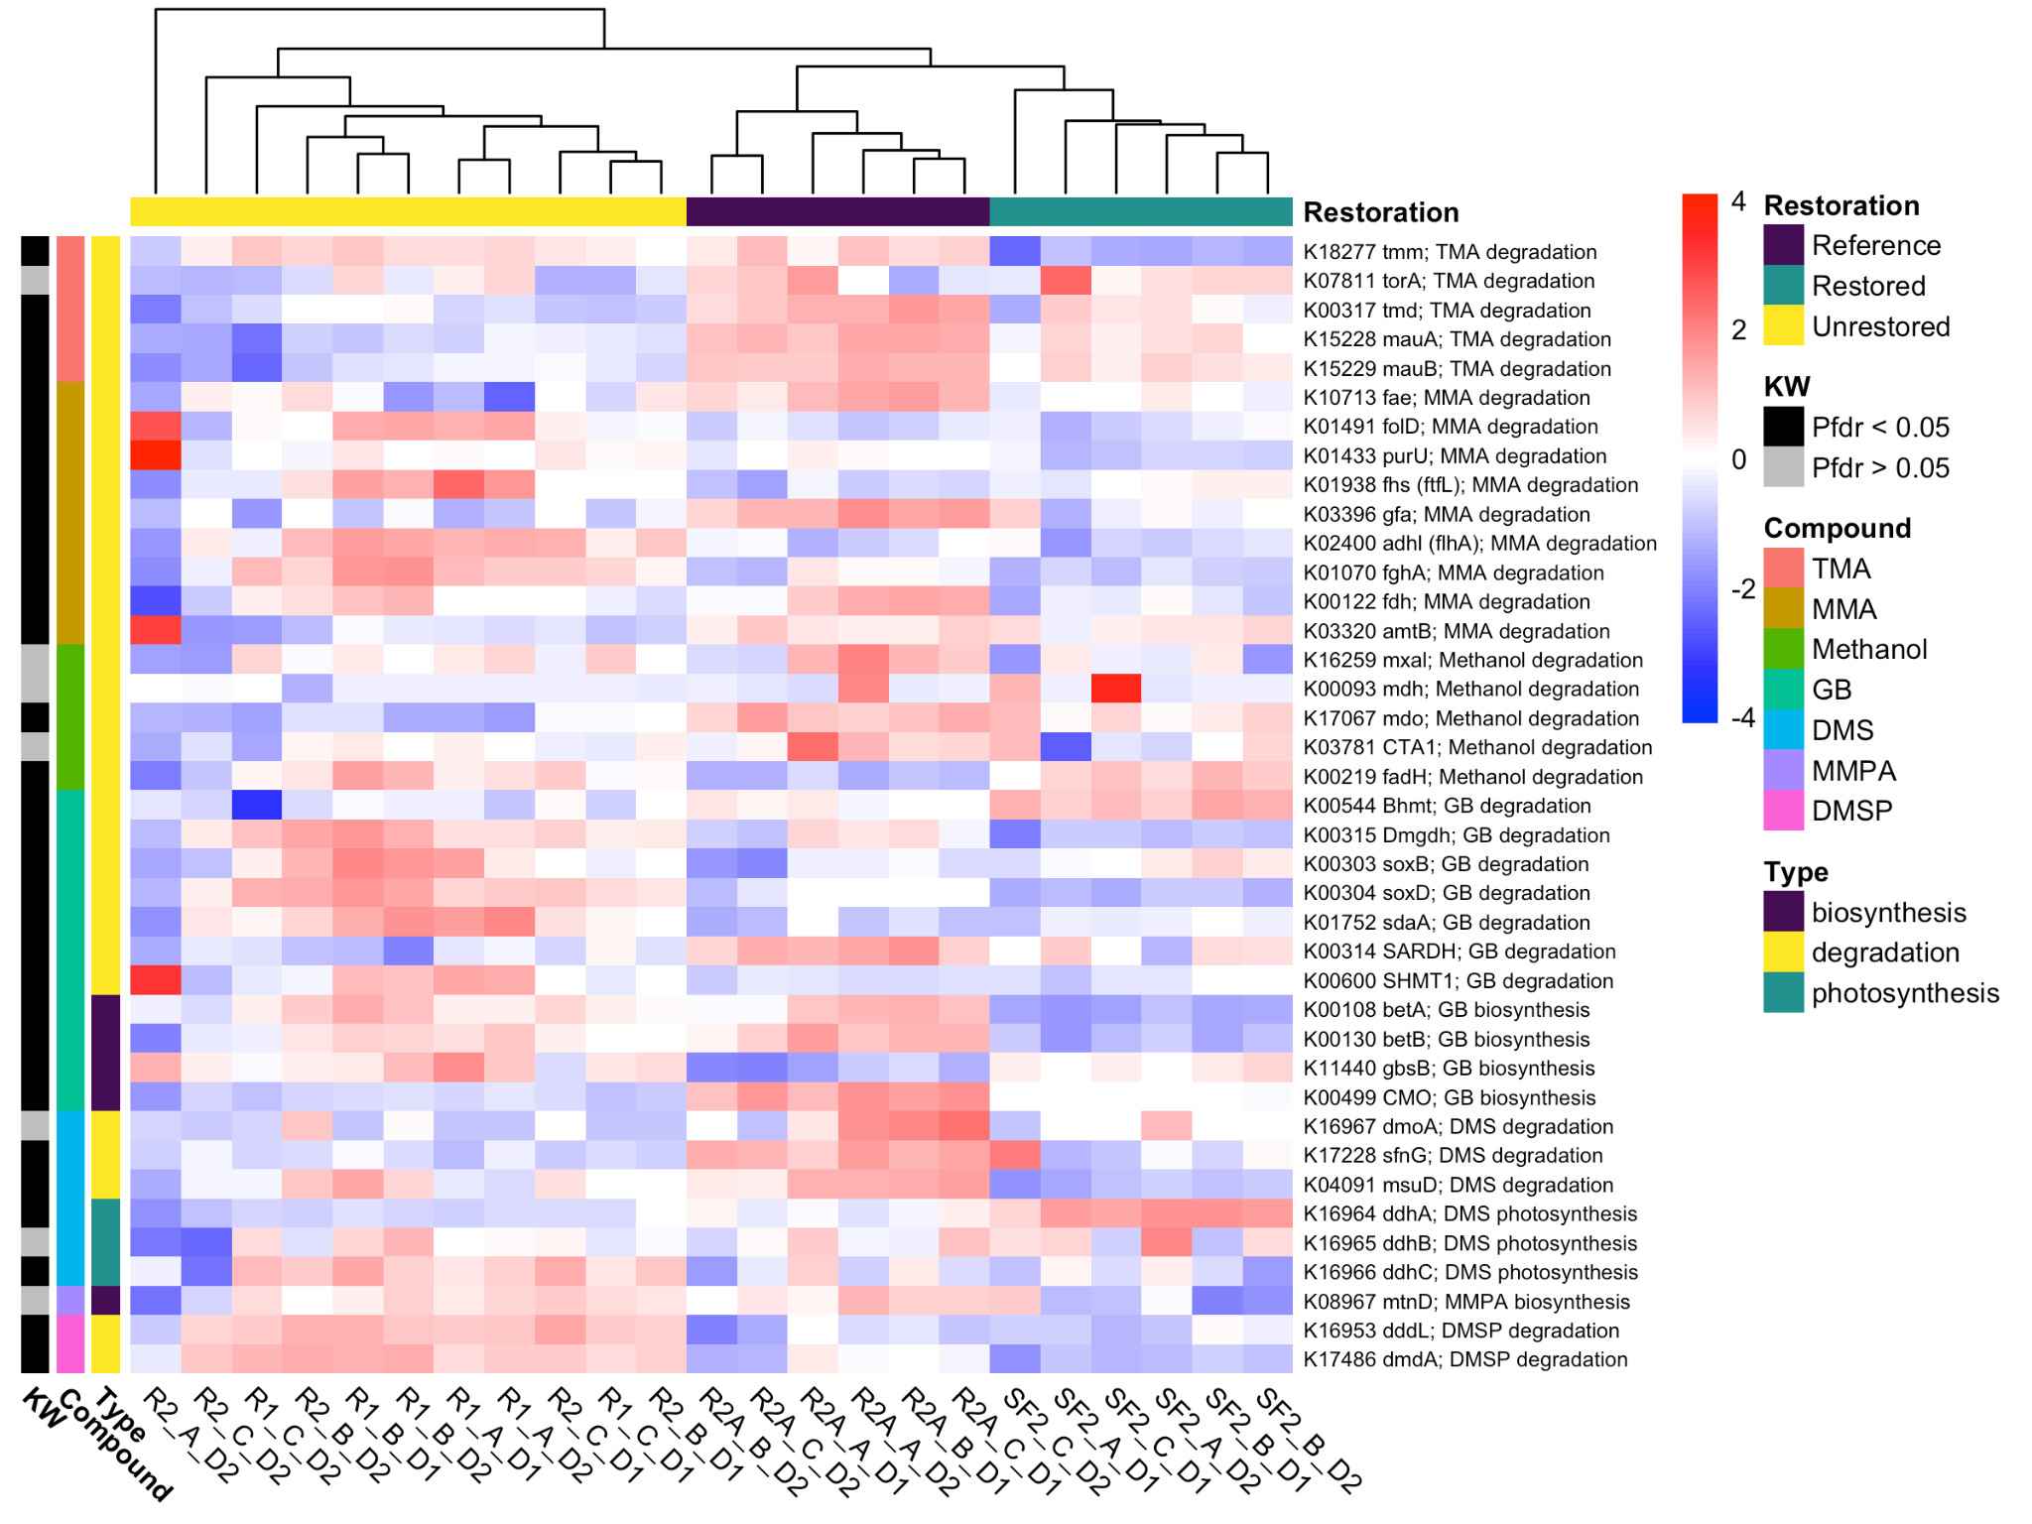Figure 1. Relative abundances of genes (z-score transformed DESeq2 normalized counts) involved in the cycling of various methylated compounds. The heatmap is clustered by sample (columns) with Ward’s D², which cleanly separates them by restoration type. Rows are sorted by compound. TMA = trimethylamine, MMA = monomethylamine, GB = glycine betaine, DMS = dimethyl sulfide, MMPA = methylthiopropanoate, DMSP = dimethylsulfoniopropionate. Rows are annotated by the compound ID, the type of process the gene is involved in, and whether the gene abundance is significantly different among the three restoration statuses based on a Kruskal-Wallis (“KW”) test with FDR p-value correction. Sample R2_A_D2 appears to be an outlier in these gene abundances; however, CH₄ emissions for core R2_A were intermediate among the unrestored samples.
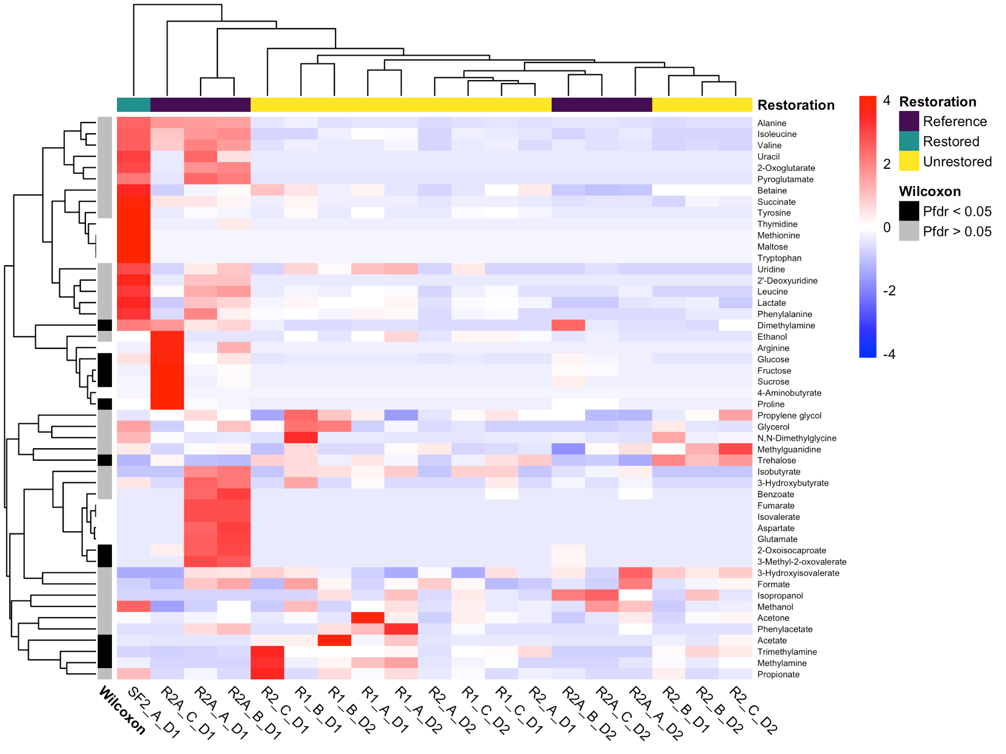

Figure 2. Concentrations of metabolites (z-score transformed µM) as measured by NMR. The heatmap is clustered by both row (metabolites) and column (samples). Columns are annotated by their restoration status, while rows are annotated by whether they are significantly different between reference and restored sites (black = Wilcoxon test, P_{FDR} < 0.05, gray = Wilcoxon test P_{FDR} > 0.05, white = present in less than 3 samples and not tested). The one restored sample was not analyzed statistically.

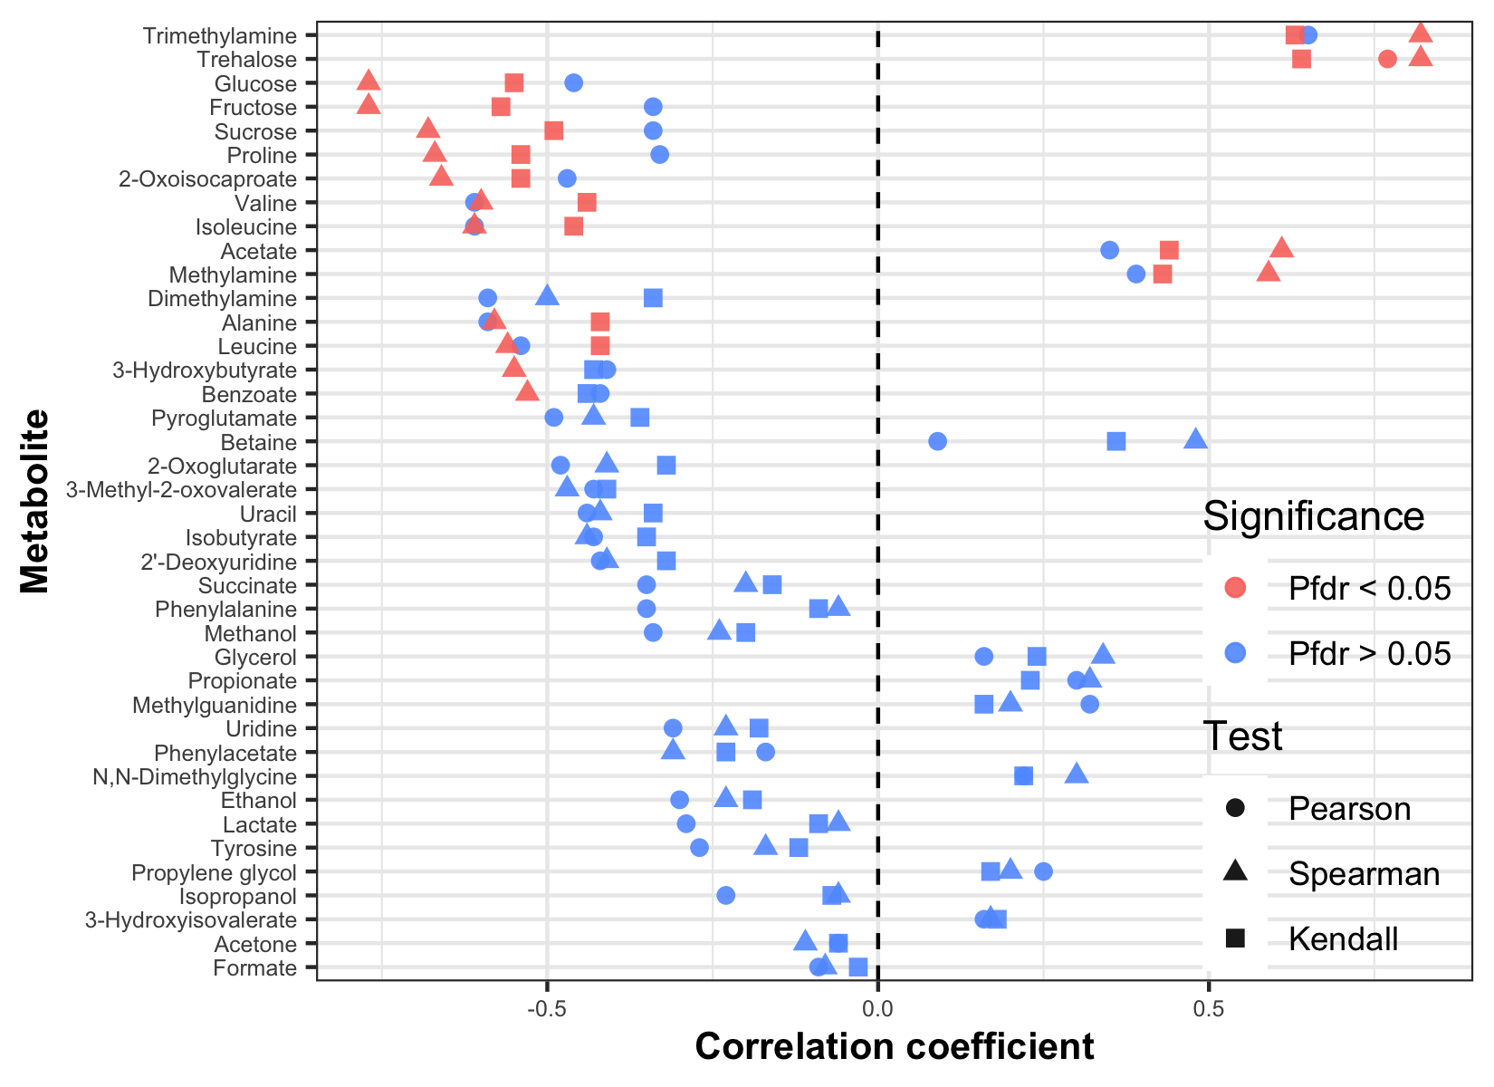Figure 3. Correlations between metabolites and methane flux. Correlations were run with 3 different types of coefficient calculations and p-values were corrected with FDR (Pfdr). The metabolites tested and shown here were each present in at least 3 samples. Note that methylphosphonic acid and dimethylmethylphosphonate are not shown here because concentrations were not quantified; however, both were detected in all analyzed samples. Methylphosphonic acid was detected only at trace levels.

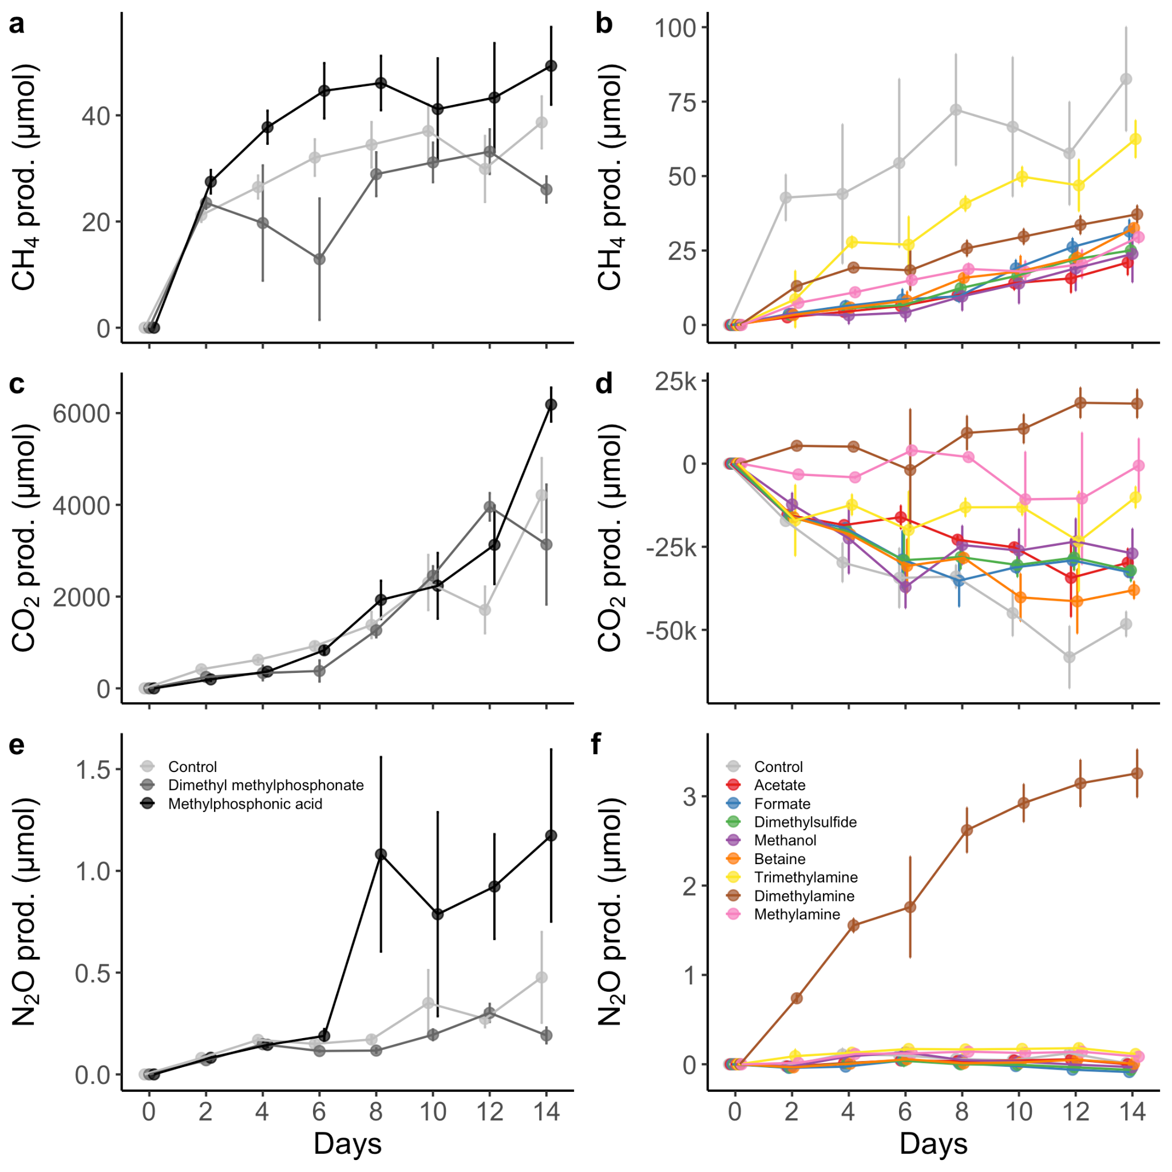Figure 4. Aerobic (left column) and anaerobic (right column) substrate addition experiment results for CH₄ (a) and (b), CO₂ (c) and (d), and N₂O (e) and (f). Shown is the cumulative amount of each gas produced over time (mean ± SE), calculated every 2 days. Aerobic substrates were methylphosphonic acid, dimethyl methylphosphonate, and controls, while anaerobic substrates were TMA, DMA, MMA, Methanol, GB, DMS, acetate, formate and controls. Note that the scale of the y-axes varies among the panels.
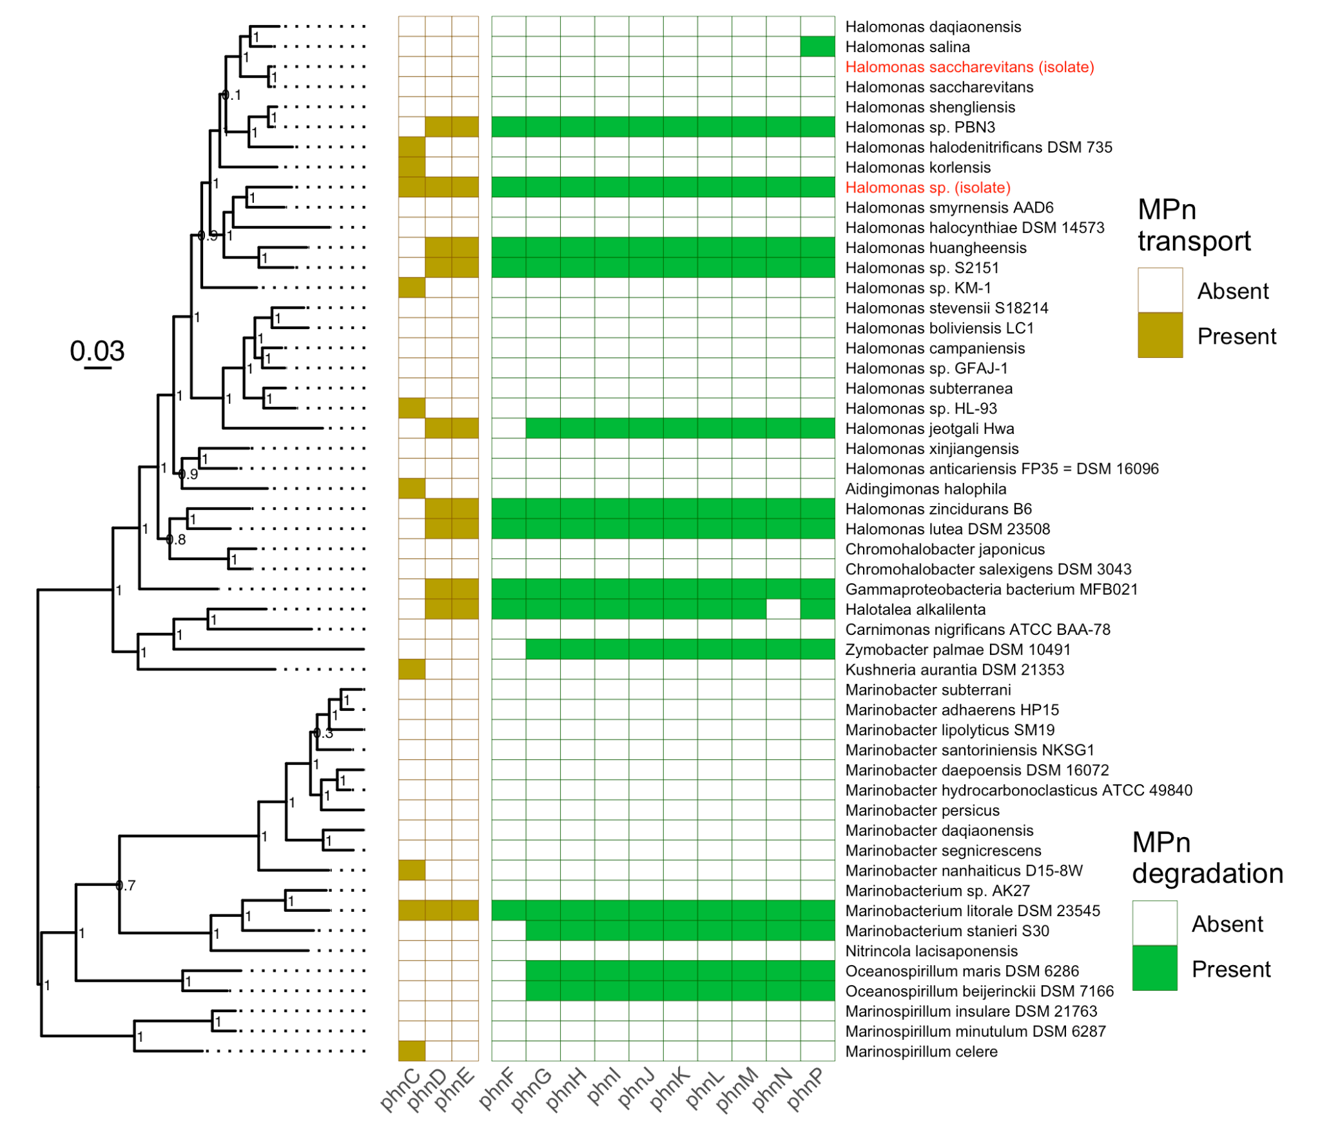

Figure 5. Phylogenetic tree and presence of methylphosphonate transport and degradation genes for the two Halomonas isolates and 50 closely related reference genomes. The phylogenetic tree was made from a concatenated alignment of 49 single copy clusters of orthologous genes.

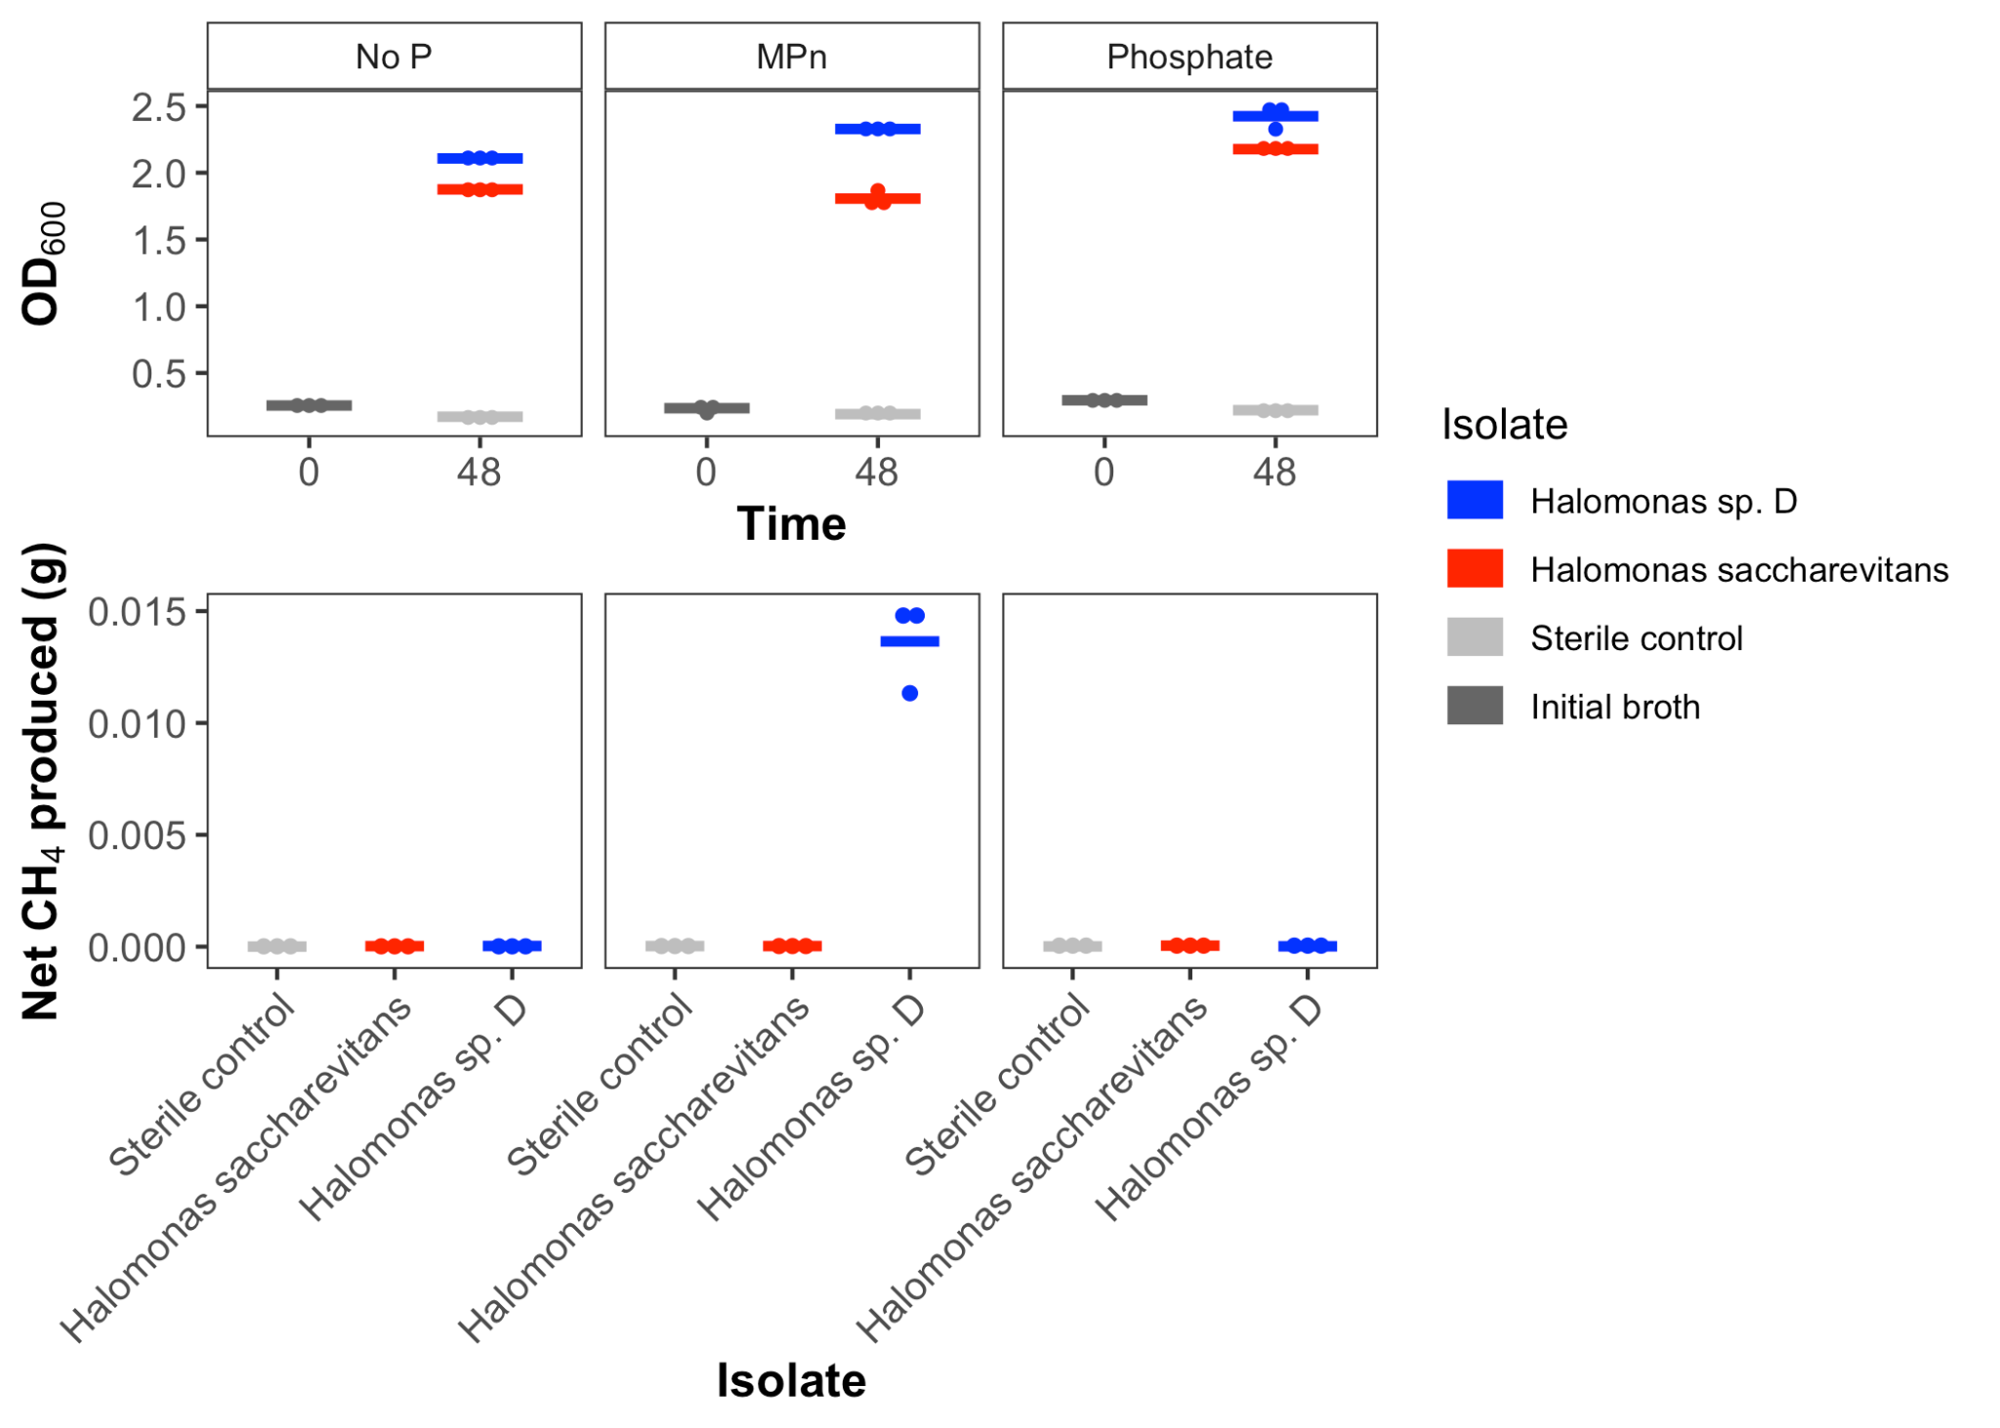Figure 6. Growth (OD₆₀₀) and net CH₄ production (g) in 48 hours by two Halomonas isolates in three different media. “Phosphate” = unaltered marine broth 2216 (Difco) which contains disodium phosphate, “MPn” = marine broth 2216 with disodium phosphate replaced by methylphosphonate as a source of phosphorus, “No P” = marine broth 2216 with no inorganic phosphorus source (but still contains organic phosphorus in yeast extract and peptone).

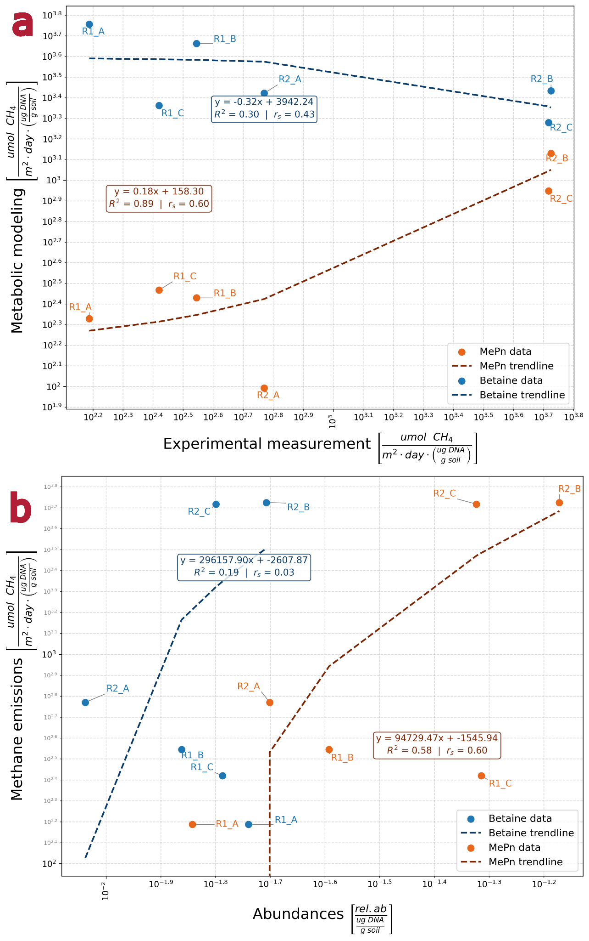

Figure 7. Assessing methylphosphonate and betaine metabolisms as potentially explaining the experimental methane emissions through linear regressions of data and metabolic modeling results. a) Experimentally observed methane emissions in each sample versus the simulated methane emissions of methylphosphonate-consuming and betaine-consuming organisms in metabolic modeling weighted by their relative abundances in each sample. The betaine predictions are colored blue while the methylphosphonate predictions are colored orange. The predicted methylphosphonate-derived methane both correlates much higher to experimental emissions than the betaine-derived methane (according to both Pearson and Spearman correlations) and better quantitatively replicates the experimental methane in its fitted equation. b) Experimentally observed methane emissions versus the relative abundances of methylphosphonate-consuming and betaine-consuming organisms in each sample. The outcome of the comparison is similar here, where methylphosphonate-consumers better explain the experimental methane flux in every metric.

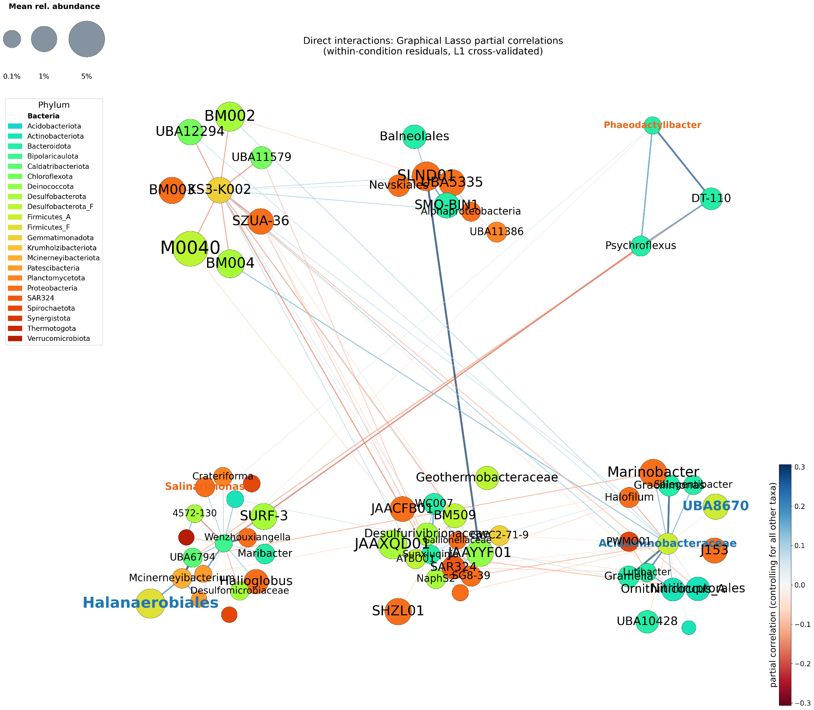
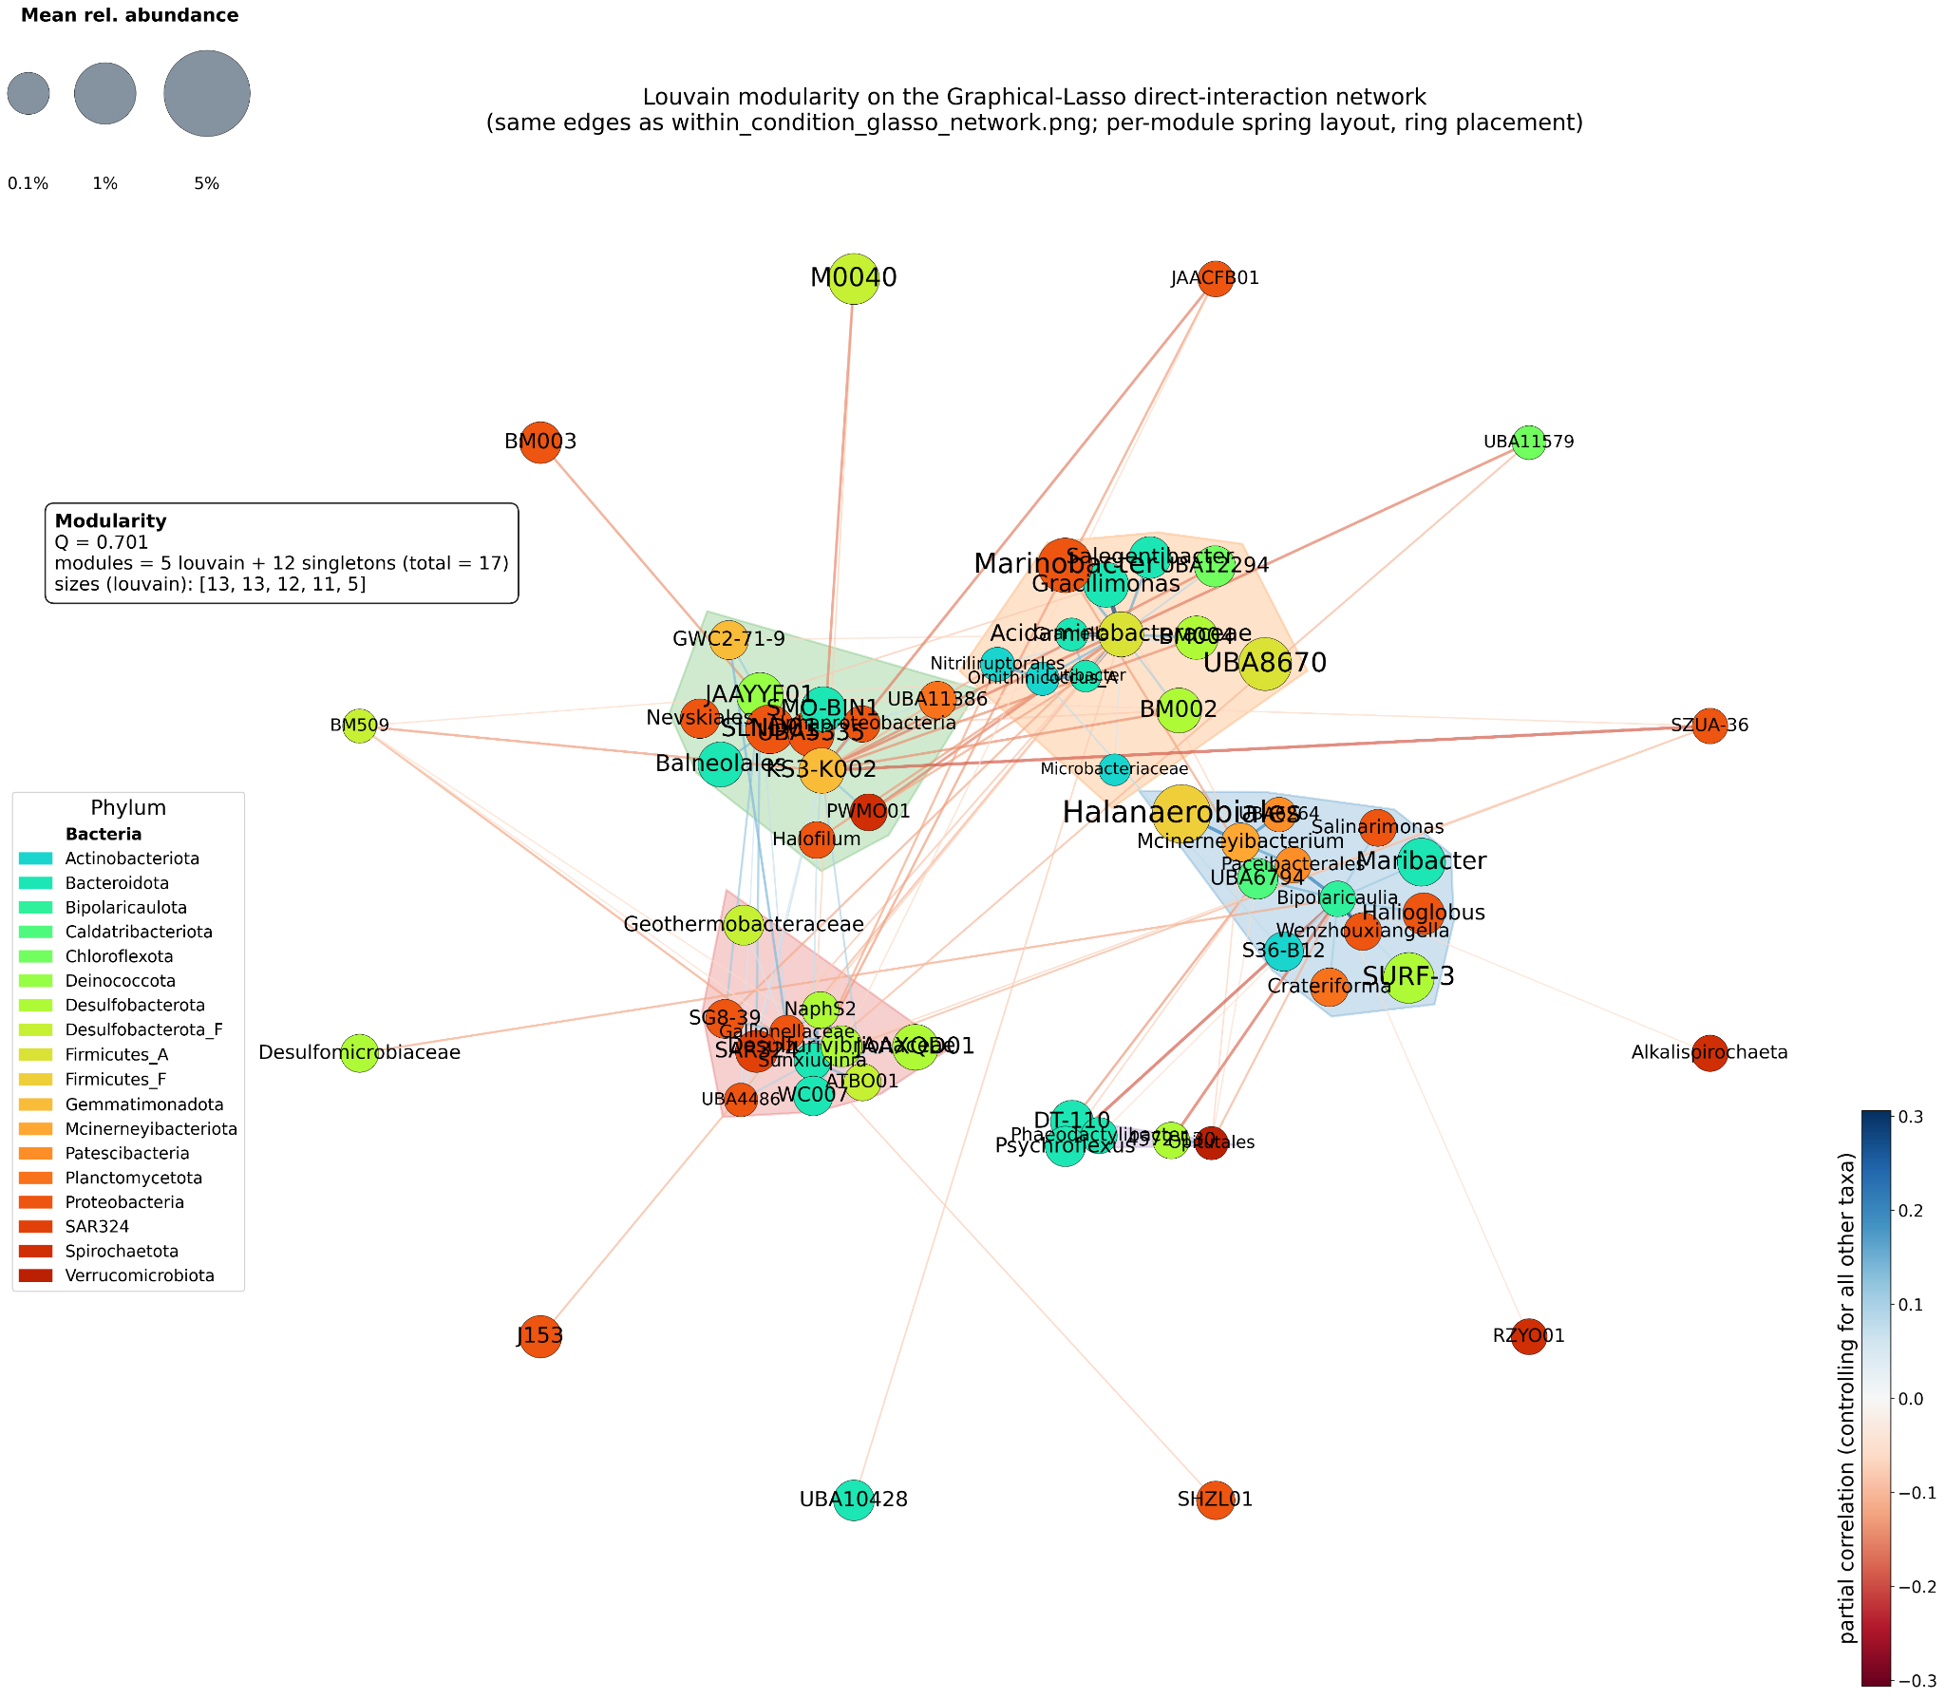

Figure 8. Co-occurrence networks that explore the relationships between the community members based on their relative abundance trends through the various samples. a) Co-occurrence network of mean relative abundance for organisms with presence (≥ 1e-5 relative abundance) in ≥ 3 experimental sites (R1, R2, R2A, SF2). Edges are inferred via graphical lasso (an L1-regularized inverse-covariance/precision matrix with the regularization strength chosen by cross-validation) fit on within-condition residuals, with surviving pairs additionally filtered by |partial r| > 0.05. Because the precision matrix conditions every pair on all other taxa simultaneously, the retained edges represent direct conditional dependencies rather than marginal co-occurrence — the L1 sparsity prior automatically discards indirect, transitive couplings that a Pearson or Spearman matrix would otherwise propagate. Node size encodes mean relative abundance, and edge color encodes the partial correlation (red = direct anticorrelation/niche partitioning, blue = direct positive coupling). Although the network appears well interconnected, Louvain community detection on the precision graph — rendered with a per-community spring layout — resolves 6 discrete sub-communities that appear to be significant functional guilds in this system. Two inferences follow: (i) the negative partial-correlation edges, especially between high-abundance taxa, are consistent with active niche partitioning or direct competitive exclusion; and (ii) betaine consumers (Acidaminobacteraceae, Halanaerobiales, UBA8670) and MePn consumers (Phaeodactylibacter, Salinarimonas) are retained as nodes whose direct couplings to non-consumer taxa are consistent with mutually reinforcing methanogenic interactions rather than incidental co-abundance, while the dropout of Roseovarius and other primary methylphosphonate consumers under L1 sparsification suggests their broad marginal correlations were largely transitive — driven through shared partners rather than direct interaction. b)

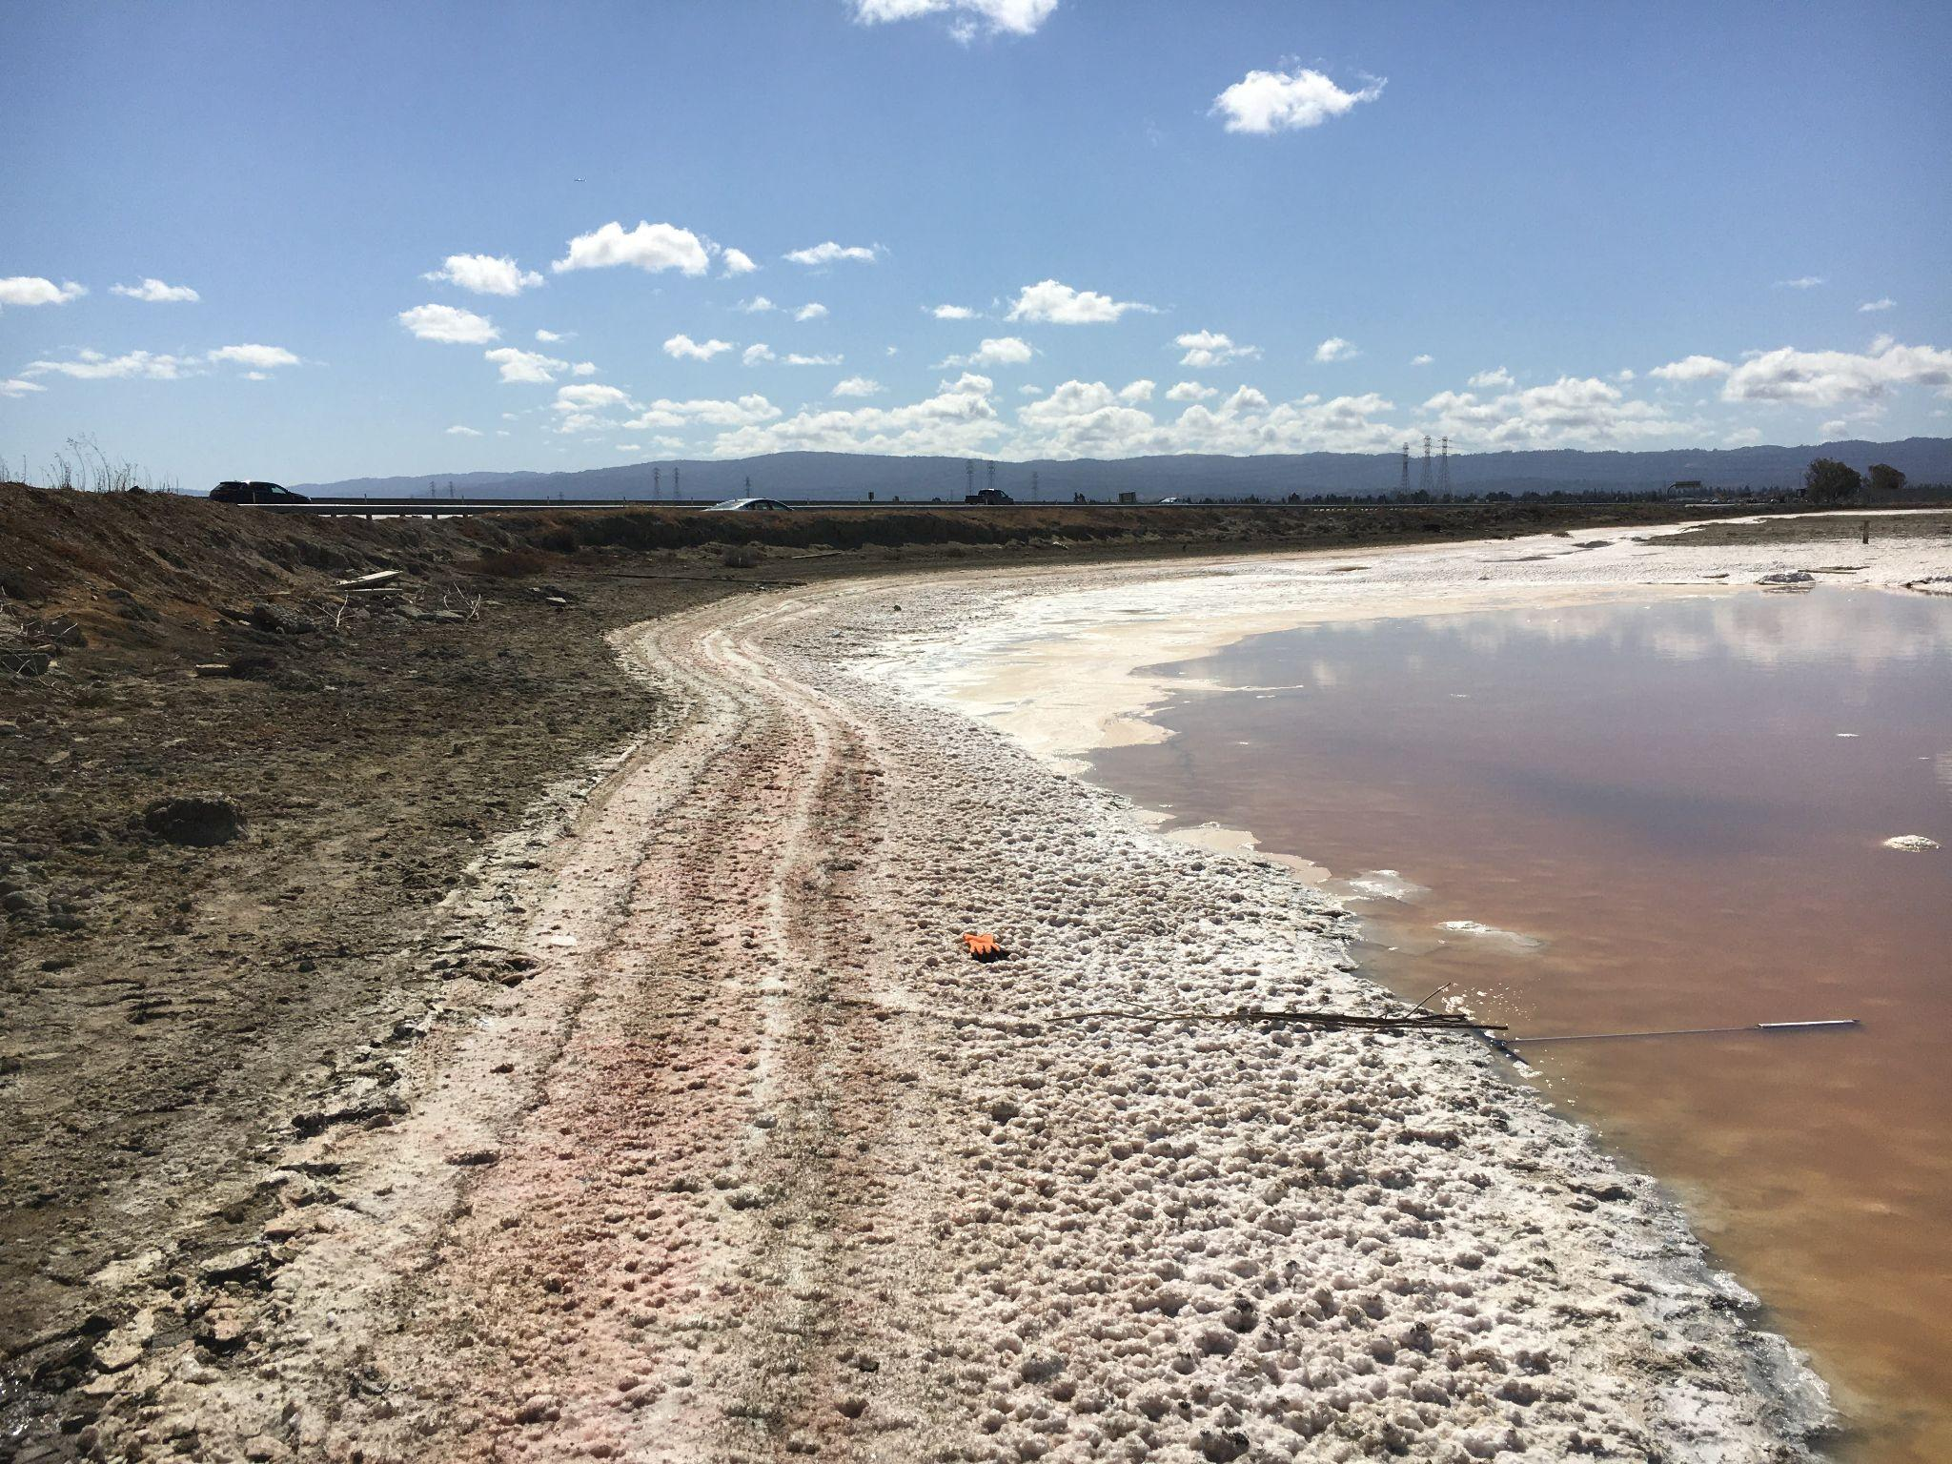Figure S1. Photo of unrestored saltern R2 in California, USA, which is characterized by a layer of solid salt crystals covered by water.

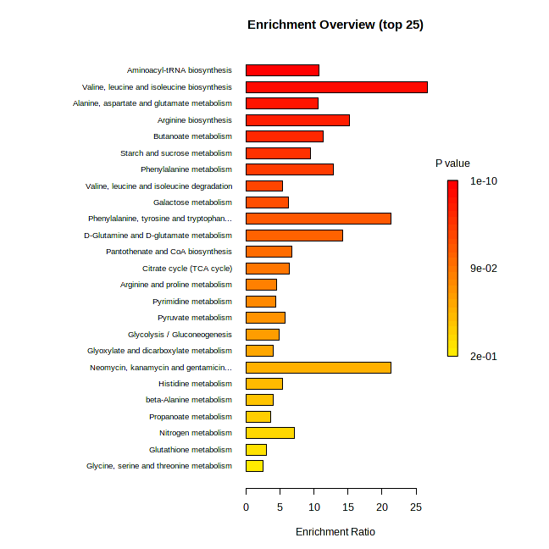Figure S2. Summary plot for Over Representation Analysis (ORA) of the quantitative NMR metabolomic data, also known as Enrichment Analysis, performed by MetaboAnalyst.

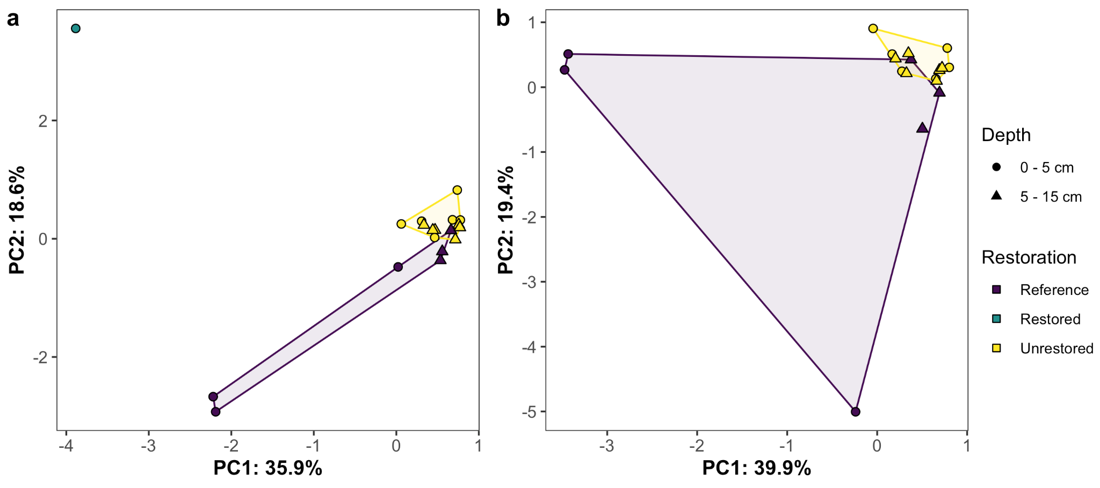Figure S3. Principal component analysis of µM concentrations of 46 metabolites as assessed with NMR for (a) unrestored salterns (n = 12), reference wetland (n = 6), and restored saltern (n = 1) sediments, and (b) same analysis but with the one restored saltern sample removed. Note the scale of the axes differs among the two panels.

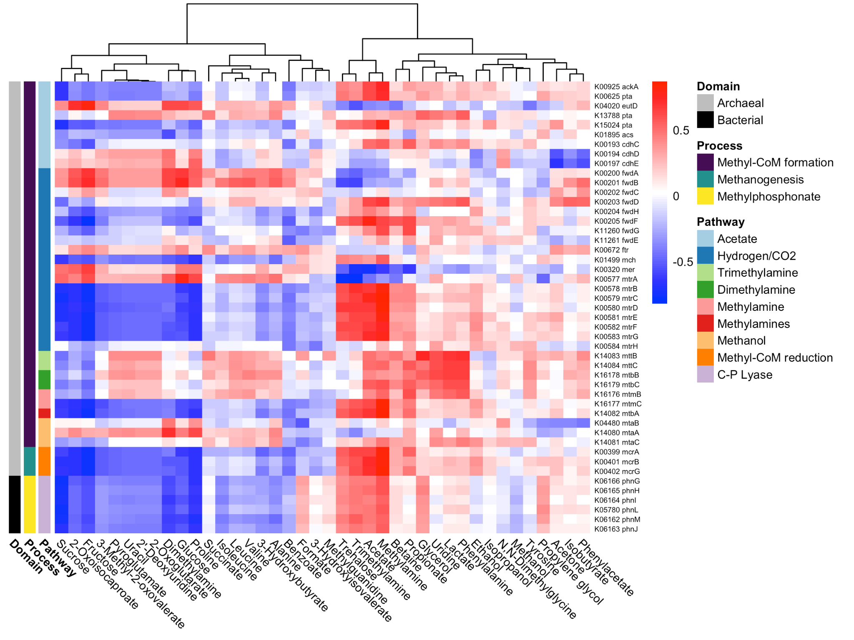Figure S4. Heatmap of Spearman correlation coefficients between metabolite abundances from NMR and gene abundances from shotgun metagenomics for genes involved in methanogenesis. The heatmap is clustered by metabolites.
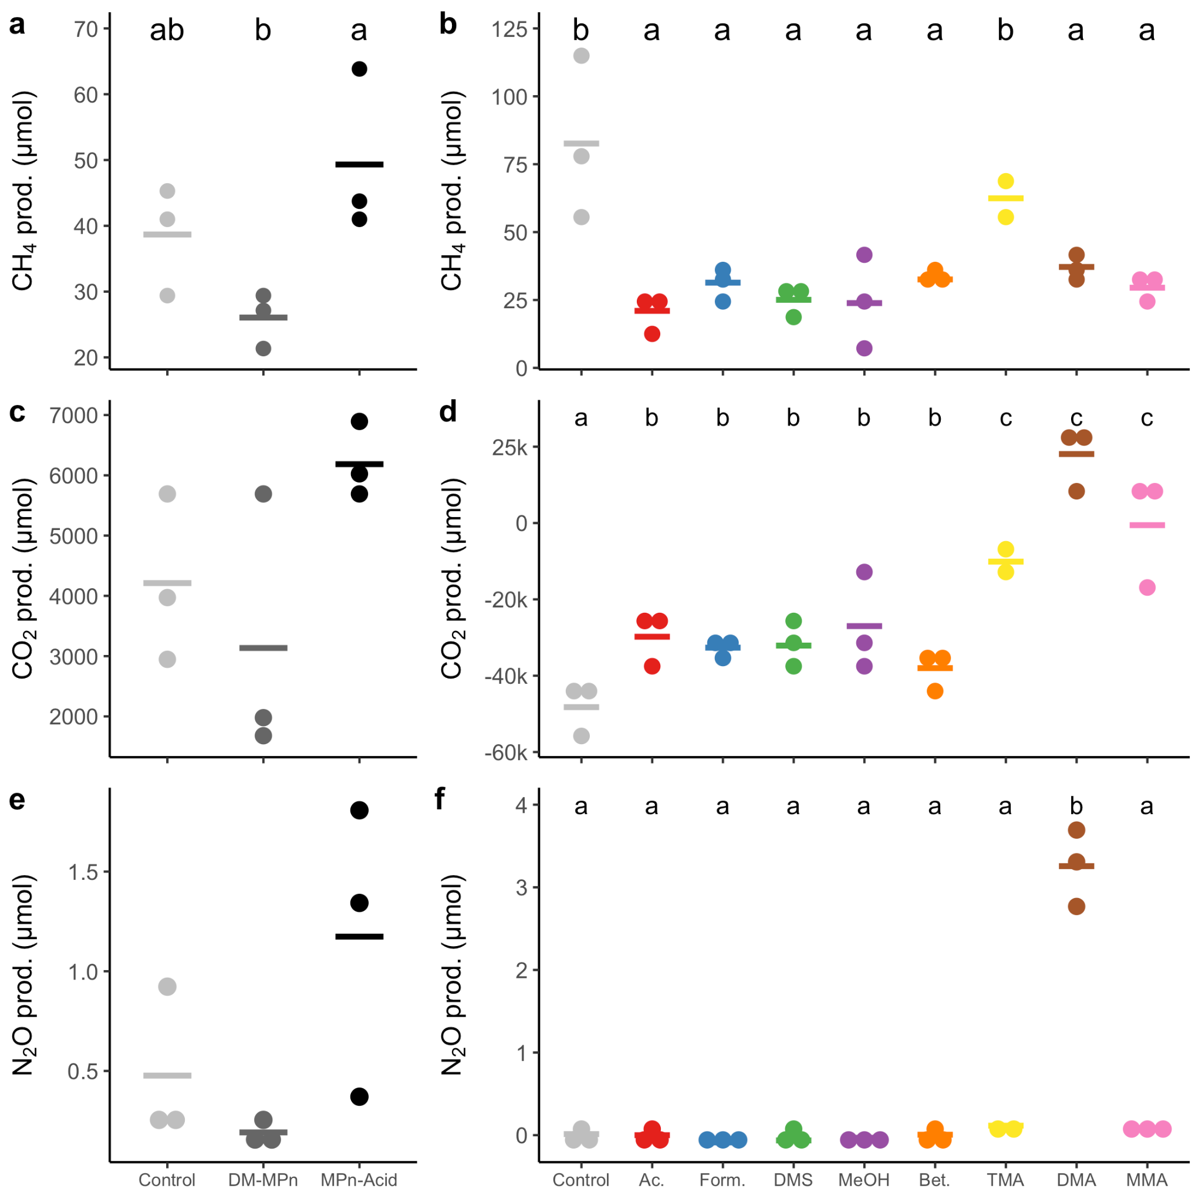

Figure S5. Total gas production by day 14 of the substrate incubation experiment for aerobic (left column, panels a, c and e) and anaerobic (right column, panels b, d, and f) oxygen conditions. Points are the raw data and lines are the means for each substrate. Different letters denote significant pairwise differences (Tukey posthoc, p < 0.05). N = 3 in all treatments but TMA, which lost 1 replicate during methods testing. DM-MPn = dimethyl methylphosphonate, MPn-Acid = methylphosphonic acid, Ac. = acetate, Form. = formate, DMS = dimethyl sulfide, MeOH = methanol, Bet. = glycine betaine, TMA = trimethylamine, DMA = dimethylamine, MMA = monomethylamine.
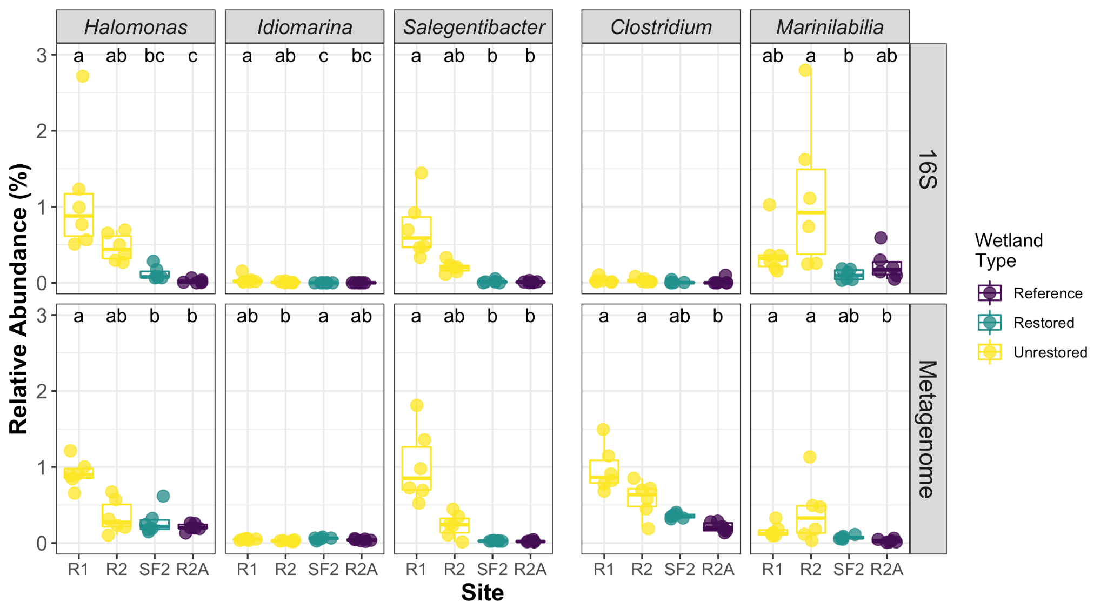

Figure S6. Relative abundance (%) of cultured genera in 16S rRNA gene data (top row) and metagenomic data (bottom row). Metagenomic abundances were computed by the IMG/M pipeline by using lastal to map contigs to the IMG reference database. 16S rRNA gene reads were analyzed with the iTagger pipeline (101), with taxonomy based on the Greengenes reference database (102).
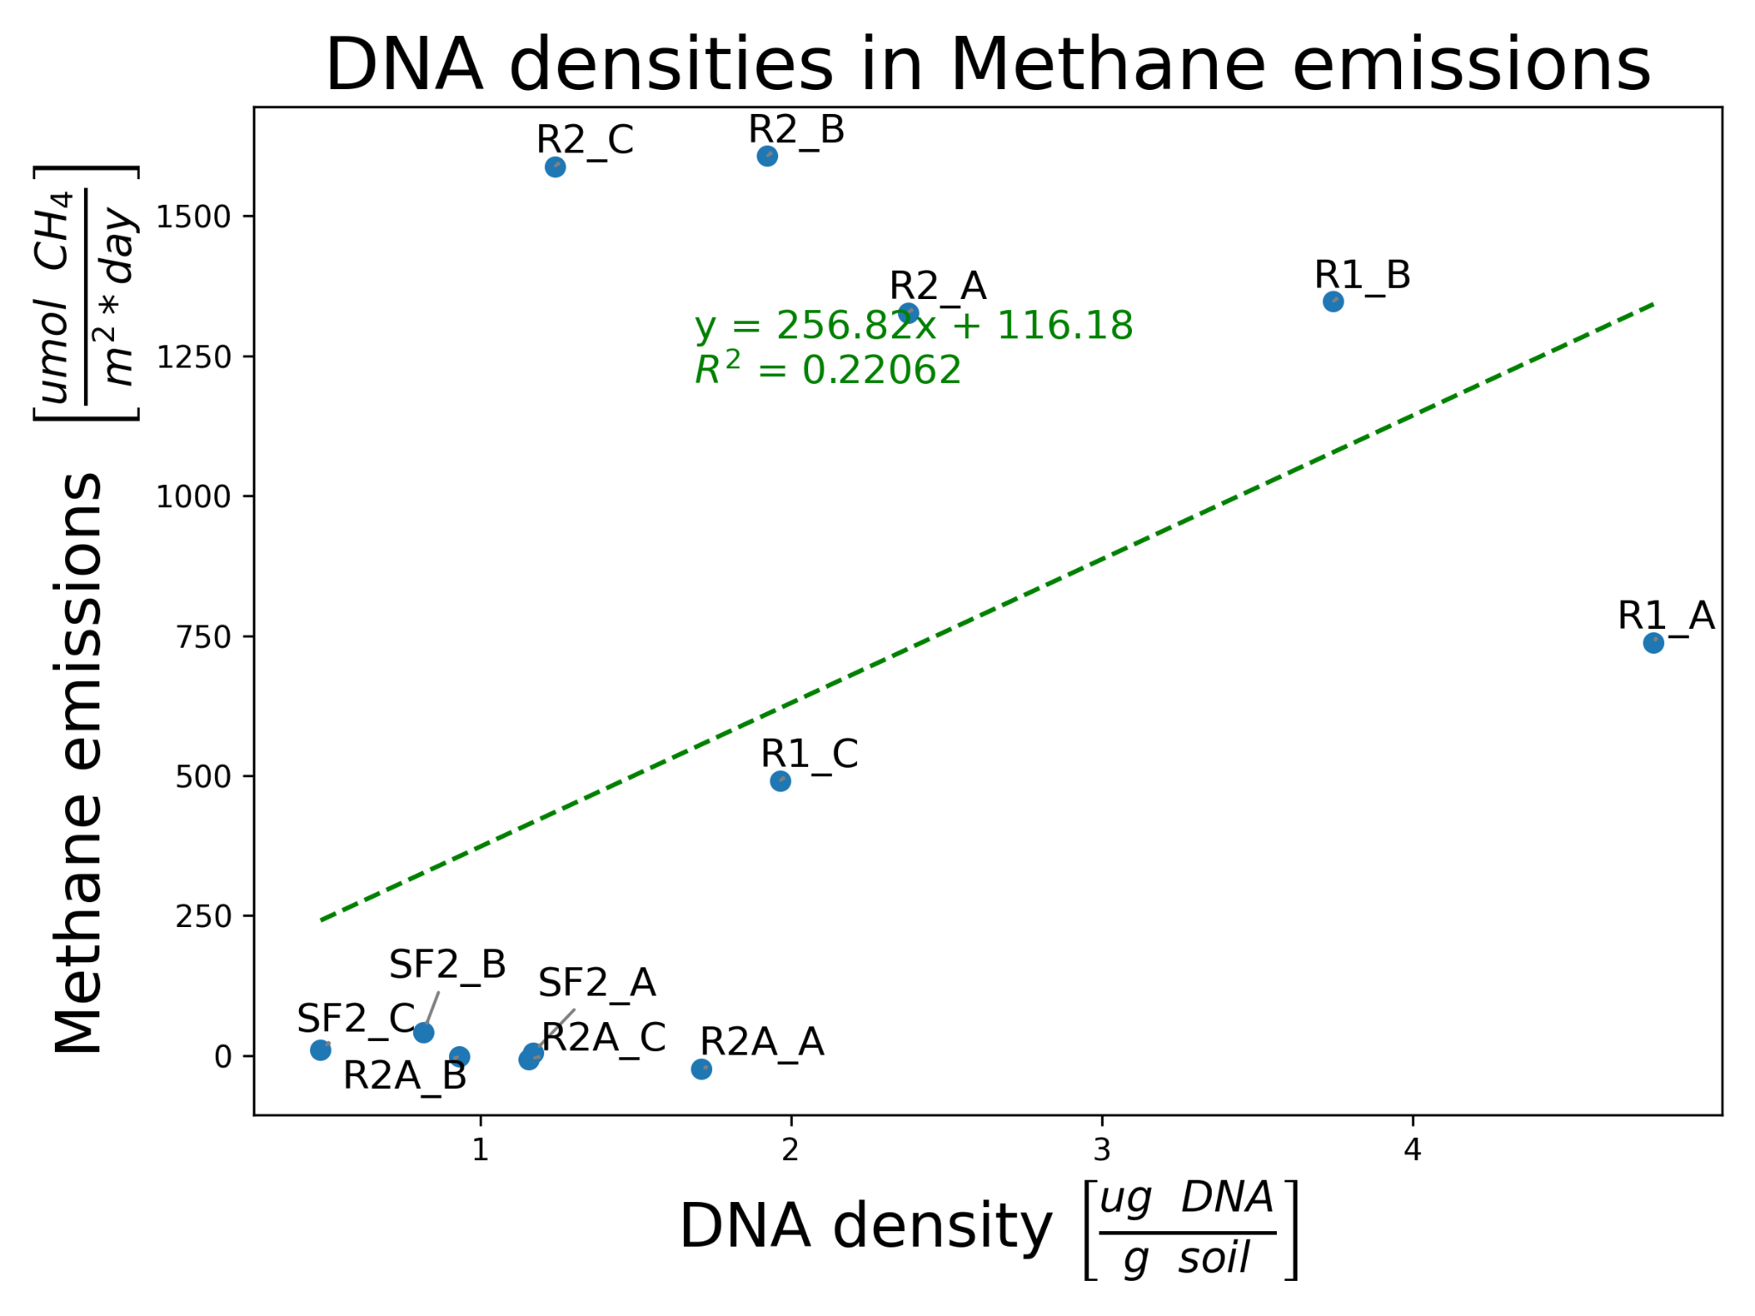

Figure S7. Experimental relationship between soil DNA density and the methane emissions of each sample. The DNA densities at depths D1 and D2 were merged into a single DNA density per sample, to match the single methane emission per sample, according to their respective volumes: ⅓ D1 and ⅔ D2. The modest correlation of methane emission to DNA density in the soil supports that methane emission is proportional to total community biomass and therefore, most importantly, that methane emission is growth associated. This further supports the methylphosphonate hypothesis as the source of methane since this compound is a vital source of phosphate for some members of the community.

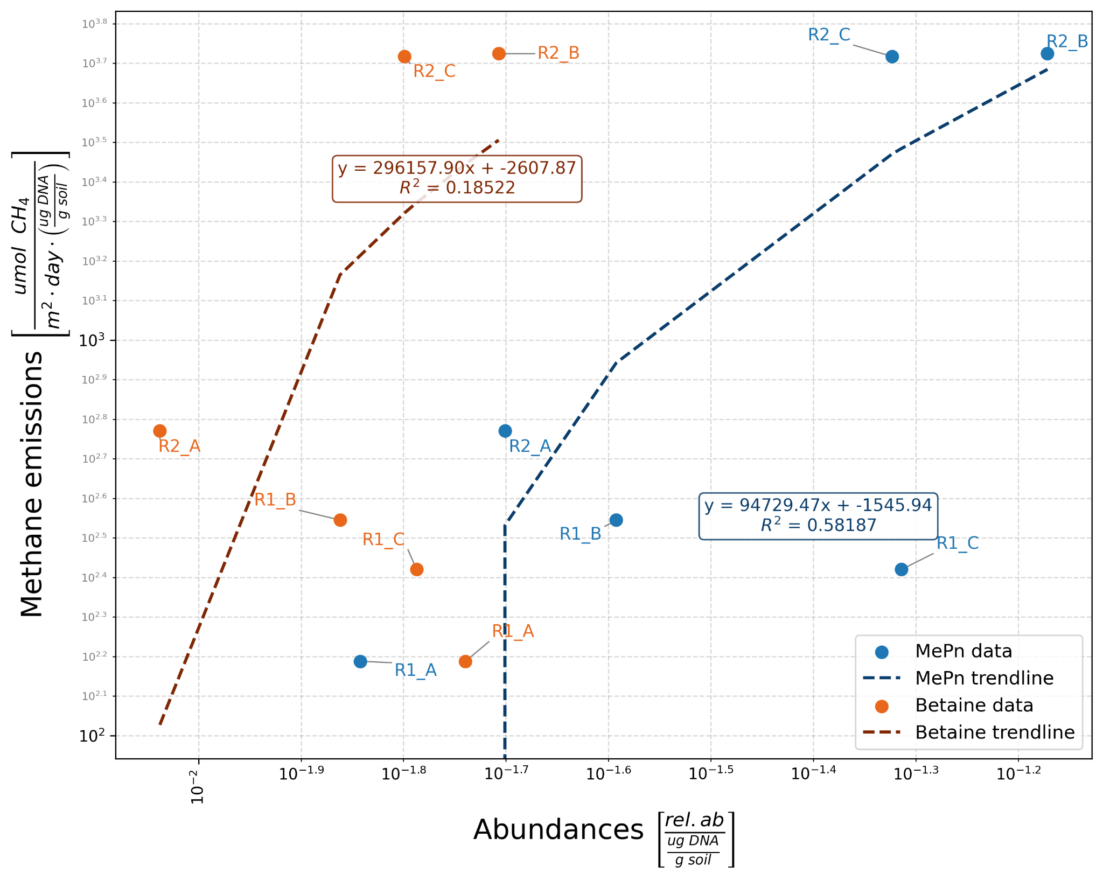

Figure S8. Correlation of total experimental abundances of methylphosphonate-consuming and betaine-consuming organisms, respectively, and methane emissions from each sample.

ne of the highest correlations among all organisms, supports from the raw data that methylphosphonate consumption is more likely involved in methane production than betaine consumption.
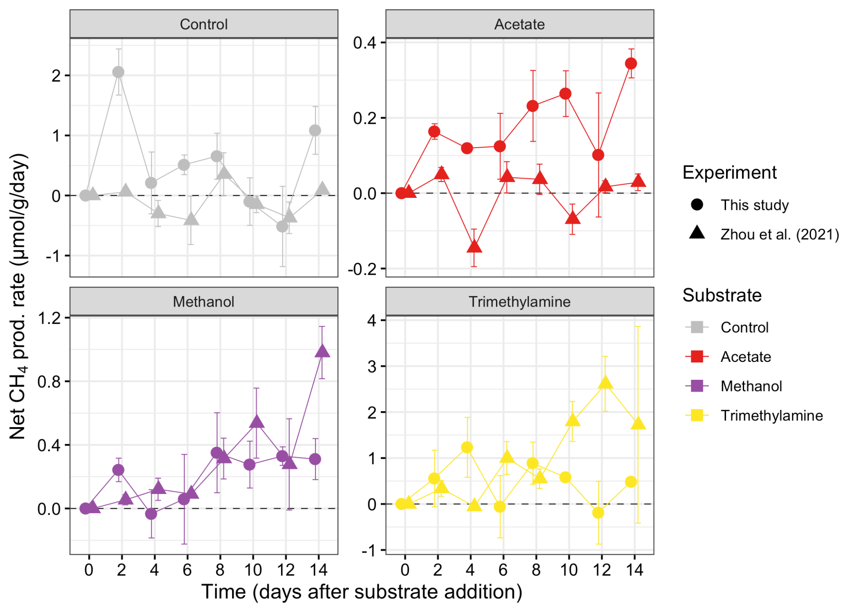

Figure S9. Comparison of CH₄ production rates in the microcosm incubation experiments performed here and published by Zhou et al. (2021). Negative values represent net consumption.

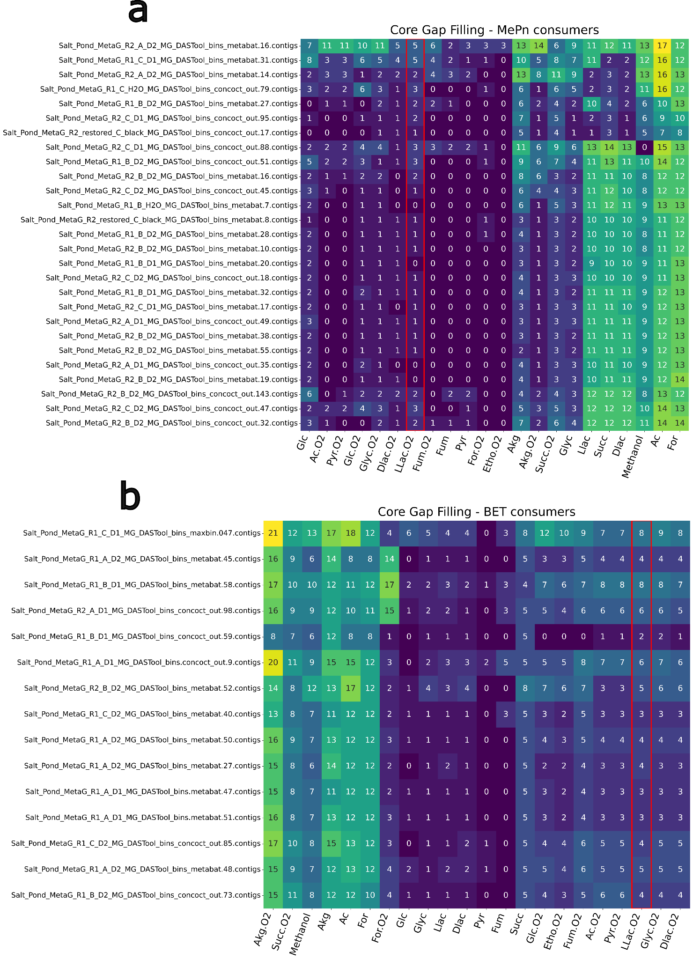

Figure S10. The reactions needed to be gapfilled into each respective a) methylphosphonate or b) betaine consumer on each of the respective carbon sources. Only anaerobic and aerobic media are included in the figure to maintain readability of the most reasonable media. The red boxed column is the aerobic L-Lactate media used for simulation of the metabolic models. L-Lactate was selected because it required among the fewest reactions to be gapfilled in both sets of organisms and is a simple sugar that leads to a relatively clean metabolic profile.

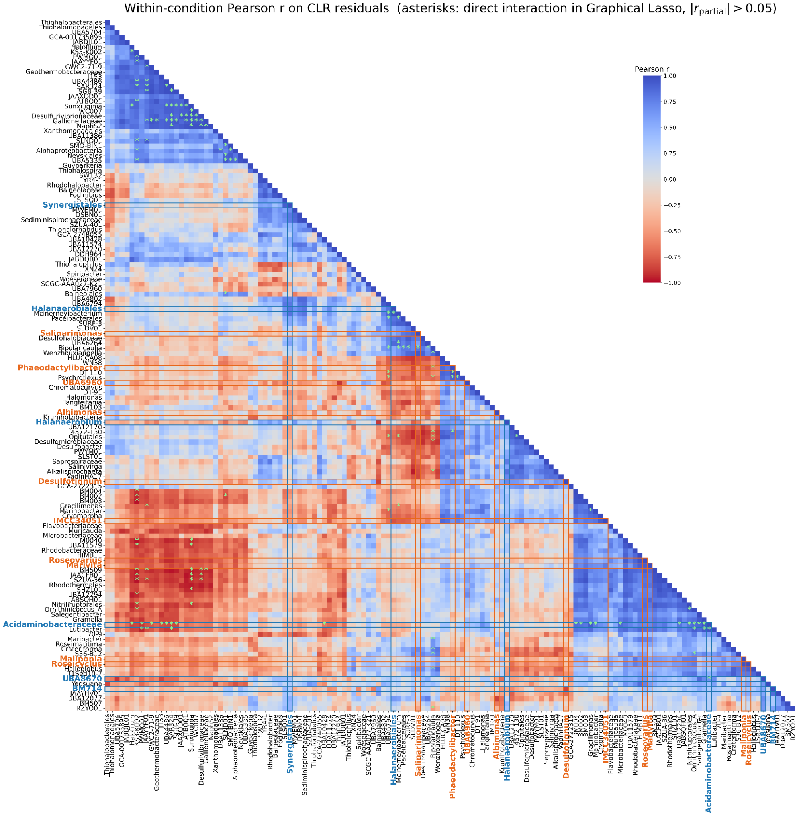

Figure S11: Co-variation clustered heatmap of prevalent taxa across the samples. The relative abundances were averaged between the two sample depths with weighting of their respective DNA densities. Taxa whose relative abundances were below 1e-5 in more than half of the samples (12 after the depth averaging) were filtered to only consider the taxa for which there was sufficient data to describe with the relative abundance data. The relative abundance data of the remaining taxa were transformed with the centered log ratio (CLR) to correct for the scale of the data, where zeros are simply below detection. The relationships among these taxa were then isolated by subtracting per-condition average abundances to remove indirect relationships. Pearson correlations are then determined for all pairs. Pairs whose correlations exceed $ρ=0.7$ are denoted with a green asterisk inside their cell. Methylphosphonate consumers and betaine consumers are further highlighted with red and blue, respectively, labels and boxed rows/columns to emphasize their particular relationships in the community.

Table S1. List of KOs involved in methylated compound cycling that were analyzed in this study.

Table S2. Table of reactions and compounds in MetaCyc that produce or consume each metabolite, and pathways each metabolite is involved in. All metabolites were present in MetaCyc except for dimethyl methylphosphonate. The list of metabolites was imported as a SmartTable and then transformed with SmartTable functions on BioCyc.

Table S3. Table of isolate cultures from unrestored salterns R1 and R2, showing the taxonomy of the top BLAST hits and % identity.

Table S4. Metadata, including IMG/M and NCBI accessions, for the 24 metagenomes in this study.

References
1. Shu W-S, Huang L-N. 2022. Microbial diversity in extreme environments. 4. Nat Rev Microbiol 20:219–235.
2. Oren A. 2013. Life at High Salt Concentrations, p. 421–440. In Rosenberg, E, DeLong, EF, Lory, S, Stackebrandt, E, Thompson, F (eds.), The Prokaryotes: Prokaryotic Communities and Ecophysiology. Springer, Berlin, Heidelberg.
3. Safarpour A, Amoozegar MA, Ventosa A. 2018. Hypersaline Environments of Iran: Prokaryotic Biodiversity and Their Potentials in Microbial Biotechnology, p. 265–298. In Egamberdieva, D, Birkeland, N-K, Panosyan, H, Li, W-J (eds.), Extremophiles in Eurasian Ecosystems: Ecology, Diversity, and Applications. Springer, Singapore.
4. Oren A. 2009. Saltern evaporation ponds as model systems for the study of primary production processes under hypersaline conditions. Aquat Microb Ecol 56:193–204.
5. Safdar H, Amin A, Shafiq Y, Ali A, Yasin R, Sarwar MI. 2019. A review: Impact of salinity on plant growth. Nat Sci 17:34–40.
6. Dragone NB, Diaz MA, Hogg ID, Lyons WB, Jackson WA, Wall DH, Adams BJ, Fierer N. 2021. Exploring the Boundaries of Microbial Habitability in Soil. J Geophys Res Biogeosciences 126:e2020JG006052.
7. Oren A. 1999. Bioenergetic Aspects of Halophilism. Microbiol Mol Biol Rev 63:334–348.
8. Lozupone CA, Knight R. 2007. Global patterns in bacterial diversity. Proc Natl Acad Sci 104:11436–11440.
9. Oren A. 2013. Life at high salt concentrations, intracellular KCl concentrations, and acidic proteomes. Front Microbiol 0.
10. Elevi Bardavid R, Oren A. 2012. Acid-shifted isoelectric point profiles of the proteins in a hypersaline microbial mat: an adaptation to life at high salt concentrations? Extremophiles 16:787–792.
11. Sorokin DY, Merkel AY, Abbas B, Makarova KS, Rijpstra WIC, Koenen M, Sinninghe Damsté JS, Galinski EA, Koonin EV, van Loosdrecht MCMY 2018. 2017. Methanonatronarchaeum thermophilum gen. nov., sp. nov. and “Candidatus Methanohalarchaeum thermophilum”, extremely halo(natrono)philic methyl-reducing methanogens from hypersaline lakes comprising a new euryarchaeal class Methanonatronarchaeia classis nov. Int J Syst Evol Microbiol 68:2199–2208.
12. Gunde-Cimerman N, Plemenitaš A, Oren A. 2018. Strategies of adaptation of microorganisms of the three domains of life to high salt concentrations. FEMS Microbiol Rev 42:353–375.
13. Ventosa A, Nieto JJ, Oren A. 1998. Biology of Moderately Halophilic Aerobic Bacteria. Microbiol Mol Biol Rev 62:504–544.
14. Roberts MF. 2005. Organic compatible solutes of halotolerant and halophilic microorganisms. Saline Syst 1:5.
15. Mcgenity T, Sorokin D. 2018. Methanogens and Methanogenesis in Hypersaline Environments, p. 1–27. In Biogenesis of Hydrocarbons. Springer International Publishing.
16. Jeffries TC, Seymour JR, Newton K, Smith RJ, Seuront L, Mitchell JG. 2012. Increases in the abundance of microbial genes encoding halotolerance and photosynthesis along a sediment salinity gradient. Biogeosciences 9:815–825.
17. Oren A. 2001. The bioenergetic basis for the decrease in metabolic diversity at increasing salt concentrations: implications for the functioning of salt lake ecosystems, p. 61–72. In Melack, JM, Jellison, R, Herbst, DB (eds.), Saline Lakes. Springer Netherlands, Dordrecht.
18. Jellison R, Melack JM. 2001. Nitrogen limitation and particulate elemental ratios of seston in hypersaline Mono Lake, California, U.S.A., p. 1–12. In Melack, JM, Jellison, R, Herbst, DB (eds.), Saline Lakes. Springer Netherlands, Dordrecht.
19. Smith SV, Veeh HH. 1989. Mass balance of biogeochemically active materials (C, N, P) in a hypersaline gulf. Estuar Coast Shelf Sci 29:195–215.
20. Cotner JB, Suplee MW, Chen NW, Shormann DE. 2004. Nutrient, sulfur and carbon dynamics in a hypersaline lagoon. Estuar Coast Shelf Sci 59:639–652.
21. Ludwig R, Pringault O, de Wit R, de Beer D, Jonkers HM. 2006. Limitation of oxygenic photosynthesis and oxygen consumption by phosphate and organic nitrogen in a hypersaline microbial mat: a microsensor study. FEMS Microbiol Ecol 57:9–17.
22. Oren A. 1990. Formation and breakdown of glycine betaine and trimethylamine in hypersaline environments. Antonie Van Leeuwenhoek 58:291–298.
23. Ticak T, Hariraju D, Arcelay MB, Arivett BA, Fiester SE, Ferguson DJ. 2015. Isolation and characterization of a tetramethylammonium-degrading Methanococcoides strain and a novel glycine betaine-utilizing Methanolobus strain. Arch Microbiol 197:197–209.
24. Creighbaum AJ, Ticak T, Shinde S, Wang X, Ferguson DJJ. 2019. Examination of the Glycine Betaine-Dependent Methylotrophic Methanogenesis Pathway: Insights Into Anaerobic Quaternary Amine Methylotrophy. Front Microbiol 10.
25. Karp PD, Billington R, Caspi R, Fulcher CA, Latendresse M, Kothari A, Keseler IM, Krummenacker M, Midford PE, Ong Q, Ong WK, Paley SM, Subhraveti P. 2019. The BioCyc collection of microbial genomes and metabolic pathways. Brief Bioinform 20:1085–1093.
26. Mitchell AD, Chappell A, Knox KL. 1979. Metabolism of Betaine in the Ruminant. J Anim Sci 49:764–774.
27. Elbein AD, Pan YT, Pastuszak I, Carroll D. 2003. New insights on trehalose: a multifunctional molecule. Glycobiology 13:17R-27R.
28. Argüelles JC. 2000. Physiological roles of trehalose in bacteria and yeasts: a comparative analysis. Arch Microbiol 174:217–224.
29. Lay C-Y, Mykytczuk NCS, Yergeau Ï, Lamarche-Gagnon G, Greer CW, Whyte LG. 2013. Defining the Functional Potential and Active Community Members of a Sediment Microbial Community in a High-Arctic Hypersaline Subzero Spring. Appl Environ Microbiol 79:3637–3648.
30. Ghai R, Pašić L, Fernández AB, Martin-Cuadrado A-B, Mizuno CM, McMahon KD, Papke RT, Stepanauskas R, Rodriguez-Brito B, Rohwer F, Sánchez-Porro C, Ventosa A, Rodríguez-Valera F. 2011. New Abundant Microbial Groups in Aquatic Hypersaline Environments. 1. Sci Rep 1:135.
31. Poffenbarger HJ, Needelman BA, Megonigal JP. 2011. Salinity influence on methane emissions from tidal marshes. Wetlands 31:831–842.
32. Al-Haj AN, Fulweiler RW. 2020. A synthesis of methane emissions from shallow vegetated coastal ecosystems. Glob Change Biol 26:2988–3005.
33. Bartlett KB, Bartlett DS, Harriss RC, Sebacher DI. 1987. Methane emissions along a salt marsh salinity gradient. Biogeochemistry 4:183–202.
34. Zhou J, Theroux SM, Bueno de Mesquita CP, Hartman WH, Tringe SG. 2021. Microbial drivers of methane emissions from unrestored industrial salt ponds. ISME J 16:284–295.
35. Sørensen K, Řeháková K, Zapomělová E, Oren A. 2009. Distribution of benthic phototrophs, sulfate reducers, and methanogens in two adjacent saltern evaporation ponds in Eilat, Israel. Aquat Microb Ecol 56:275–284.
36. Oren A. 2014. Taxonomy of halophilic Archaea: current status and future challenges. Extremophiles 18:825–834.
37. Sorokin DY. 2021. Microbial Utilization of Glycine Betain in Hypersaline Soda Lakes. Microbiology 90:569–577.
38. Conrad R. 2020. Importance of hydrogenotrophic, aceticlastic and methylotrophic methanogenesis for methane production in terrestrial, aquatic and other anoxic environments: A mini review. Pedosphere 30:25–39.
39. Karl DM, Beversdorf L, Björkman KM, Church MJ, Martinez A, Delong EF. 2008. Aerobic production of methane in the sea. 7. Nat Geosci 1:473–478.
40. del Valle D, Karl D. 2014. Aerobic production of methane from dissolved water-column methylphosphonate and sinking particles in the North Pacific Subtropical Gyre. Aquat Microb Ecol 73:93–105.
41. Martínez A, Ventouras L-A, Wilson ST, Karl DM, Delong EF. 2013. Metatranscriptomic and functional metagenomic analysis of methylphosphonate utilization by marine bacteria. Front Microbiol 4:340.
42. Repeta DJ, Ferrón S, Sosa OA, Johnson CG, Repeta LD, Acker M, DeLong EF, Karl DM. 2016. Marine methane paradox explained by bacterial degradation of dissolved organic matter. 12. Nat Geosci 9:884–887.
43. Metcalf WW, Griffin BM, Cicchillo RM, Gao J, Janga SC, Cooke HA, Circello BT, Evans BS, Martens-Habbena W, Stahl DA, Donk WA van der. 2012. Synthesis of methylphosphonic acid by marine microbes: a source for methane in the aerobic ocean. Science 337:1104–1107.
44. Bueno de Mesquita CP, Zhou J, Theroux S, Tringe SG. 2022. Methylphosphonate Degradation and Salt-Tolerance Genes of Two Novel Halophilic Marivita Metagenome-Assembled Genomes from Unrestored Solar Salterns. 1. Genes 13:148.
45. Dugan HA, Summers JC, Skaff NK, Krivak-Tetley FE, Doubek JP, Burke SM, Bartlett SL, Arvola L, Jarjanazi H, Korponai J, Kleeberg A, Monet G, Monteith D, Moore K, Rogora M, Hanson PC, Weathers KC. 2017. Long-term chloride concentrations in North American and European freshwater lakes. 1. Sci Data 4:170101.
46. Li D, Liu C-M, Luo R, Sadakane K, Lam T-W. 2015. MEGAHIT: an ultra-fast single-node solution for large and complex metagenomics assembly via succinct de Bruijn graph. Bioinforma Oxf Engl 31:1674–1676.
47. Chen I-MA, Chu K, Palaniappan K, Ratner A, Huang J, Huntemann M, Hajek P, Ritter S, Varghese N, Seshadri R, Roux S, Woyke T, Eloe-Fadrosh EA, Ivanova NN, Kyrpides NC. 2021. The IMG/M data management and analysis system v.6.0: new tools and advanced capabilities. Nucleic Acids Res 49:D751–D763.
48. Love MI, Huber W, Anders S. 2014. Moderated estimation of fold change and dispersion for RNA-seq data with DESeq2. Genome Biol 15:550.
49. Sun J, Mausz MA, Chen Y, Giovannoni SJ. 2019. Microbial trimethylamine metabolism in marine environments. Environ Microbiol 21:513–520.
50. Chen Y. 2012. Comparative genomics of methylated amine utilization by marine Roseobacter clade bacteria and development of functional gene markers (tmm, gmaS). Environ Microbiol 14:2308–2322.
51. Arkin AP, Cottingham RW, Henry CS, Harris NL, Stevens RL, Maslov S, Dehal P, Ware D, Perez F, Canon S, Sneddon MW, Henderson ML, Riehl WJ, Murphy-Olson D, Chan SY, Kamimura RT, Kumari S, Drake MM, Brettin TS, Glass EM, Chivian D, Gunter D, Weston DJ, Allen BH, Baumohl J, Best AA, Bowen B, Brenner SE, Bun CC, Chandonia J-M, Chia J-M, Colasanti R, Conrad N, Davis JJ, Davison BH, DeJongh M, Devoid S, Dietrich E, Dubchak I, Edirisinghe JN, Fang G, Faria JP, Frybarger PM, Gerlach W, Gerstein M, Greiner A, Gurtowski J, Haun HL, He F, Jain R, Joachimiak MP, Keegan KP, Kondo S, Kumar V, Land ML, Meyer F, Mills M, Novichkov PS, Oh T, Olsen GJ, Olson R, Parrello B, Pasternak S, Pearson E, Poon SS, Price GA, Ramakrishnan S, Ranjan P, Ronald PC, Schatz MC, Seaver SMD, Shukla M, Sutormin RA, Syed MH, Thomason J, Tintle NL, Wang D, Xia F, Yoo H, Yoo S, Yu D. 2018. KBase: The United States Department of Energy Systems Biology Knowledgebase. 7. Nat Biotechnol 36:566–569.
52. Allen BH, Gupta N, Edirisinghe JN, Faria JP, Henry CS. 2022. Application of the Metabolic Modeling Pipeline in KBase to Categorize Reactions, Predict Essential Genes, and Predict Pathways in an Isolate Genome, p. 291–320. In Navid, A (ed.), Microbial Systems Biology: Methods and Protocols. Springer US, New York, NY.
53. Aziz RK, Bartels D, Best AA, DeJongh M, Disz T, Edwards RA, Formsma K, Gerdes S, Glass EM, Kubal M, Meyer F, Olsen GJ, Olson R, Osterman AL, Overbeek RA, McNeil LK, Paarmann D, Paczian T, Parrello B, Pusch GD, Reich C, Stevens R, Vassieva O, Vonstein V, Wilke A, Zagnitko O. 2008. The RAST Server: Rapid Annotations using Subsystems Technology. BMC Genomics 9:75.
54. Lai M-C, Hong T-Y, Gunsalus RP. 2000. Glycine Betaine Transport in the Obligate Halophilic Archaeon Methanohalophilus portucalensis. J Bacteriol 182:5020–5024.
55. Oren A, Gurevich P. 1994. Production of d-lactate, acetate, and pyruvate from glycerol in communities of halophilic archaea in the Dead Sea and in saltern crystallizer ponds. FEMS Microbiol Ecol 14:147–155.
56. Oren A. 2015. Pyruvate: A key Nutrient in Hypersaline Environments? Microorganisms 3:407–416.
57. Covey KR, de Mesquita CPB, Oberle B, Maynard DS, Bettigole C, Crowther TW, Duguid MC, Steven B, Zanne AE, Lapin M, Ashton MS, Oliver CD, Lee X, Bradford MA. 2016. Greenhouse trace gases in deadwood. Biogeochemistry 130:215–226.
58. Bueno de Mesquita CP, Zhou J, Theroux SM, Tringe SG. 2021. Methanogenesis and salt tolerance genes of a novel halophilic Methanosarcinaceae metagenome-assembled genome from a former solar saltern. Genes 12:1609.
59. Chen S-C, Huang H-H, Lai M-C, Weng C-Y, Chiu H-H, Tang S-L, Rogozin DY, Degermendzhy AG. 2018. Methanolobus psychrotolerans sp. nov., a psychrotolerant methanoarchaeon isolated from a saline meromictic lake in Siberia. Int J Syst Evol Microbiol 68:1378–1383.
60. Shen Y, Chen S-C, Lai M-C, Huang H-H, Chiu H-H, Tang S-L, Rogozin DY, Degermendzhy AG. 2020. Methanolobus halotolerans sp. nov., isolated from the saline Lake Tus in Siberia. Int J Syst Evol Microbiol 70:5586–5593.
61. Wu S-Y, Lai M-C. 2011. Methanogenic Archaea Isolated from Taiwan’s Chelungpu Fault. Appl Environ Microbiol 77:830–838.
62. Angel R, Claus P, Conrad R. 2012. Methanogenic archaea are globally ubiquitous in aerated soils and become active under wet anoxic conditions. 4. ISME J 6:847–862.
63. Kearse M, Moir R, Wilson A, Stones-Havas S, Cheung M, Sturrock S, Buxton S, Cooper A, Markowitz S, Duran C, Thierer T, Ashton B, Meintjes P, Drummond A. 2012. Geneious Basic: An integrated and extendable desktop software platform for the organization and analysis of sequence data. Bioinformatics 28:1647–1649.
64. Babraham Bioinformatics - FastQC A Quality Control tool for High Throughput Sequence Data. https://www.bioinformatics.babraham.ac.uk/projects/fastqc/. Retrieved 6 July 2023.
65. Schmieder R, Edwards R. 2011. Quality control and preprocessing of metagenomic datasets. Bioinformatics 27:863–864.
66. Bankevich A, Nurk S, Antipov D, Gurevich AA, Dvorkin M, Kulikov AS, Lesin VM, Nikolenko SI, Pham S, Prjibelski AD, Pyshkin AV, Sirotkin AV, Vyahhi N, Tesler G, Alekseyev MA, Pevzner PA. 2012. SPAdes: a new genome assembly algorithm and its applications to single-cell sequencing. J Comput Biol 19:455–477.
67. Parks DH, Imelfort M, Skennerton CT, Hugenholtz P, Tyson GW. 2015. CheckM: assessing the quality of microbial genomes recovered from isolates, single cells, and metagenomes. Genome Res 25:1043–1055.
68. Chaumeil P-A, Mussig AJ, Hugenholtz P, Parks DH. 2020. GTDB-Tk: a toolkit to classify genomes with the Genome Taxonomy Database. Bioinformatics 36:1925–1927.
69. Kanehisa M, Sato Y, Morishima K. 2016. BlastKOALA and GhostKOALA: KEGG Tools for Functional Characterization of Genome and Metagenome Sequences. J Mol Biol 428:726–731.
70. R Core Team. 2023. R: A Language and Environment for Statistical Computing. https://www.R-project.org/.
71. Pang Z, Chong J, Zhou G, de Lima Morais DA, Chang L, Barrette M, Gauthier C, Jacques P-É, Li S, Xia J. 2021. MetaboAnalyst 5.0: narrowing the gap between raw spectra and functional insights. Nucleic Acids Res 49:W388–W396.
72. Kolde R. pheatmap: Pretty Heatmaps. R package version 1.0.12. https://CRAN.R-project.org/package=pheatmap. 2019. (R package version 1.0.12). R.
73. Bates D, Mächler M, Bolker BM, Walker SC. 2015. Fitting linear mixed-effects models using lme4. J Stat Softw 67:1–48.
74. Fox J, Weisberg S. 2018. An R Companion to Applied Regression, 3rd ed. SAGE Publications, Thousand Oaks, CA.
75. Lenth RV. 2021. emmeans: Estimated Marginal Means, aka Least-Squares Means (R package version 1.7.0). R.
76. Hartman WH, Bueno de Mesquita CP, Theroux SM, Morgan-Lang C, Baldocchi DD, Tringe SG. 2024. Multiple microbial guilds mediate soil methane cycling along a wetland salinity gradient. mSystems e00936-23.
77. Sosa OA, Repeta DJ, DeLong EF, Ashkezari MD, Karl DM. 2019. Phosphate-limited ocean regions select for bacterial populations enriched in the carbon–phosphorus lyase pathway for phosphonate degradation. Environ Microbiol 21:2402–2414.
78. Li G-W, Zhang X-Y, Wang C-S, Zhang Y-J, Xu X-W, Liu C, Li H, Liu A, Xu Z, Song X-Y, Chen X-L, Zhou B-C, Zhang Y-Z. 2013. Albimonas pacifica sp. nov., isolated from seawater of the Pacific, and emended description of the genus Albimonas. Int J Syst Evol Microbiol 63:3597–3601.
79. Chandra G, Chater KF, Bornemann S 2011. 2011. Unexpected and widespread connections between bacterial glycogen and trehalose metabolism. Microbiology 157:1565–1572.
80. Sosa OA, Repeta DJ, Ferrón S, Bryant JA, Mende DR, Karl DM, DeLong EF. 2017. Isolation and Characterization of Bacteria That Degrade Phosphonates in Marine Dissolved Organic Matter. Front Microbiol 8.
81. Zhuang G-C, Elling FJ, Nigro LM, Samarkin V, Joye SB, Teske A, Hinrichs K-U. 2016. Multiple evidence for methylotrophic methanogenesis as the dominant methanogenic pathway in hypersaline sediments from the Orca Basin, Gulf of Mexico. Geochim Cosmochim Acta 187:1–20.
82. Kiene RP, Oremland RS, Catena A, Miller LG, Capone DG. 1986. Metabolism of Reduced Methylated Sulfur Compounds in Anaerobic Sediments and by a Pure Culture of an Estuarine Methanogen. Appl Environ Microbiol 52:1037–1045.
83. Lomans BP, Op den Camp HJ, Pol A, van der Drift C, Vogels GD. 1999. Role of methanogens and other bacteria in degradation of dimethyl sulfide and methanethiol in anoxic freshwater sediments. Appl Environ Microbiol 65:2116–2121.
84. Oremland RS, Marsh L, DesMarais DJ. 1982. Methanogenesis in Big Soda Lake, Nevada: an Alkaline, Moderately Hypersaline Desert Lake. Appl Environ Microbiol 43:462–468.
85. Oremland RS, Kiene RP, Mathrani I, Whiticar MJ, Boone DR. 1989. Description of an Estuarine Methylotrophic Methanogen Which Grows on Dimethyl Sulfide. Appl Environ Microbiol 55:994–1002.
86. Guo H, Yu Z, Liu R, Zhang H, Zhong Q, Xiong Z. 2012. Methylotrophic methanogenesis governs the biogenic coal bed methane formation in Eastern Ordos Basin, China. Appl Microbiol Biotechnol 96:1587–1597.
87. Kim SG, Bae HS, Lee ST. 2001. A novel denitrifying bacterial isolate that degrades trimethylamine both aerobically and anaerobically via two different pathways. Arch Microbiol 176:271–277.
88. Kim S-G, Bae H-S, Oh H-M, Lee S-T. 2003. Isolation and characterization of novel halotolerant and/or halophilic denitrifying bacteria with versatile metabolic pathways for the degradation of trimethylamine. FEMS Microbiol Lett 225:263–269.
89. Mustakhimov I, Kalyuzhnaya MG, Lidstrom ME, Chistoserdova L. 2013. Insights into denitrification in Methylotenera mobilis from denitrification pathway and methanol metabolism mutants. J Bacteriol 195:2207–2211.
90. Kurth JM, Op den Camp HJM, Welte CU. 2020. Several ways one goal—methanogenesis from unconventional substrates. Appl Microbiol Biotechnol 104:6839–6854.
91. Londry KL, Dawson KG, Grover HD, Summons RE, Bradley AS. 2008. Stable carbon isotope fractionation between substrates and products of Methanosarcina barkeri. Org Geochem 39:608–621.
92. Torres-Alvarado R, Ramírez-Vives F, Fernández FJ, Barriga-Sosa I. 2005. Methanogenesis and methane oxidation in wetlands: Implications in the global carbon cycle. Hidrobiológica 15:327–349.
93. Zhang R, Wang S, Wang C, Wang G-Y, Du Z-J 2019. 2019. Marinilabilia rubra sp. nov., isolated from a marine solar saltern. Int J Syst Evol Microbiol 69:914–919.
94. Shalley S, Pradip Kumar S, Srinivas TNR, Suresh K, Anil Kumar P. 2013. Marinilabilia nitratireducens sp. nov., a lipolytic bacterium of the family Marinilabiliaceae isolated from marine solar saltern. Antonie Van Leeuwenhoek 103:519–525.
95. Taborda M, Antunes A, Tiago I, Veríssimo A, Nobre MF, da Costa MS. 2009. Description of Idiomarina insulisalsae sp. nov., isolated from the soil of a sea salt evaporation pond, proposal to transfer the species of the genus Pseudidiomarina to the genus Idiomarina and emended description of the genus Idiomarina. Syst Appl Microbiol 32:371–378.
96. Bowman JP. 2016. Salegentibacter, p. 1–11. In Bergey’s Manual of Systematics of Archaea and Bacteria. John Wiley & Sons, Ltd.
97. Martínez-Cánovas MJ, Béjar V, Martínez-Checa F, Páez R, Quesada E 2004. 2004. Idiomarina fontislapidosi sp. nov. and Idiomarina ramblicola sp. nov., isolated from inland hypersaline habitats in Spain. Int J Syst Evol Microbiol 54:1793–1797.
98. Thauer RK, Jungermann K, Henninger H, Wenning J, Decker K. 1968. The Energy Metabolism of Clostridium kluyveri. Eur J Biochem 4:173–180.
99. Lebrun M, Mainil JG, Linden A. 2010. Cattle enterotoxaemia and Clostridium perfringens : description, diagnosis and prophylaxis. Vet Rec 167:13–22.
100. Ventosa A, de la Haba RR, Arahal DR, Sánchez-Porro C. 2021. Halomonas, p. 1–111. In Bergey’s Manual of Systematics of Archaea and Bacteria. John Wiley & Sons, Ltd.
101. Tremblay J, Singh K, Fern A, Kirton ES, He S, Woyke T, Lee J, Chen F, Dangl JL, Tringe SG. 2015. Primer and platform effects on 16S rRNA tag sequencing. Front Microbiol 6.
102. DeSantis TZ, Hugenholtz P, Larsen N, Rojas M, Brodie EL, Keller K, Huber T, Dalevi D, Hu P, Andersen GL. 2006. Greengenes, a Chimera-Checked 16S rRNA Gene Database and Workbench Compatible with ARB. Appl Environ Microbiol 72:5069–5072.

